Ross Sea Region Projections

Background to LINZS25008 Standard for Ross Sea Region Geodetic Datum 2000 Projections

21 March 2011


www.linz.govt.nz
Table of Contents
1 Introduction 3
2 Existing Ross Sea Region Projections 4
2.1 Darwin Glacier Lambert Conformal 2000 4
2.2 Universal Transverse Mercator and Universal Polar Stereographic 5
2.3 International Map of the World 6
2.4 Transformation Parameters 7
3 Ross Sea Region Projections 8
3.1 Introduction 8
3.2 McMurdo Sound Lambert Conformal 2000 9
3.3 Borchgrevink Coast Lambert Conformal 2000 10
3.4 Pennell Coast Lambert Conformal 2000 11
3.5 Ross Sea Polar Stereographic 2000 12

Introduction
The Ross Sea Region Geodetic Datum 2000 (RSRGD2000) was implemented as the official datum for the Ross Sea Region of Antarctica in 2000. This superseded several local datums that had been used previously. The RSRGD2000 is formally defined in LINZS25001 Standard for Ross Sea Region Geodetic Datum 2000, published in November 2007.
When the RSRGD2000 was published, consideration was also given to the publication of a series of map projections to facilitate consistent mapping throughout the region. At that time it was decided there was little need for published projections in the Ross Sea. Instead, LINZ chose to adopt a process of endorsing projections which were proposed by cartographers producing maps in an area. This was seen to be sufficient to ensure that LINZ mapping products were produced on consistent and well defined datums.
It has also become apparent since the publication of RSRGD2000 and the Darwin Glacier Lambert Conformal 2000 projection (see section 2.1 below) that, while the approach of endorsing projections on a case-by-case basis is satisfactory for LINZ’s mapping activities, it does not provide a convenient and consistent spatial reference framework for other users.
To enable the consistent representation of geospatial data throughout the Ross Sea, it is therefore desirable for a set of projections to be defined. The provision of the reference system will encourage the collection and representation of spatial data in a consistent and transparent way.

Existing Ross Sea Region Projections

Darwin Glacier Lambert Conformal 2000
The Darwin Glacier Lambert Conformal 2000 (DGLC2000) projection (Figure 1) was developed following this approach and a standard published (LINZS25007 Darwin Glacier Lambert Conformal 2000 Projection) in November 2008. It provides a projection to support topographic mapping in the vicinity of the Darwin Glacier. The mapping products covering the Darwin Glacier have been compiled, but not published for the public.
The DGLC2000 was optimised for mapping around the Darwin Glacier. LINZ now intends to publish maps of Ross Island. It can be seen in Figure 1 that the eastern edge of Ross Island (Cape Crozier) falls outside the extent of the DGLC2000. Also, the map distortion over Ross Island will be high due to its distance from the projection’s central meridian. The DGLC2000 is therefore not an appropriate projection for use with Ross Island mapping.

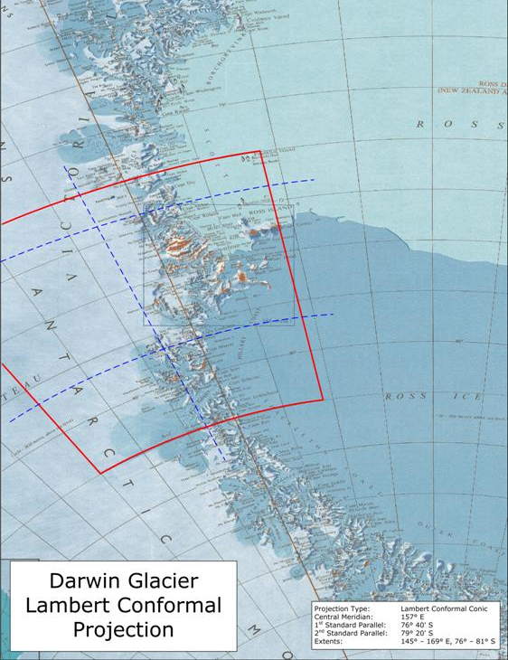
Figure 1 – Darwin Glacier Lambert Conformal 2000

Universal Transverse Mercator and Universal Polar Stereographic
The Universal Transverse Mercator (UTM) and Universal Polar Stereographic (UPS) coordinate systems and the Military Grid Reference System (MGRS) provide coverage over the Ross Sea Region. UTM extends to 80°S, with the Ross Sea Region being covered by nine zones, 57S – 5S. The UPS south zone extends from the South Pole to 80°S. Positions in terms of both UTM and UPS can be described in terms of the MGRS
UTM zones become very narrow at their southern extents. In practice, this means the western sector of the Ross Sea Region is covered by three zones (57S, 58S, 59S), with the zone boundaries occurring in the middle of areas of interest. For example, the boundary between 58S and 59S occurs in the middle of Ross Island. The use of UTM would not facilitate LINZ’s intended production of a Ross Island topographic map, and would require geospatial data within the island to be presented in terms of different projections. UTM is therefore not a desirable projection method in the Ross Sea Region.
The UPS south zone has its origin at the South Pole (which has a coordinate of 2,000,000 mN, 2,000,000 mE) and a longitude origin of 0° E/W. The UPS false origin means that northing and easting ordinates can be numerically similar, leading to potential confusion among users. Also, the direction of the UPS longitude origin means that projection coordinates in the Ross Sea Region would get numerically smaller when travelling in a northerly direction. UPS South is not appropriate for the Ross Sea Region.
MGRS is primarily a military mapping system that has received very little uptake outside the military sector. An MGRS coordinate is given as a grid reference rather than a northing/easting pair. The grid references are a combination of letters and numbers that are not intuitive to non-expert users. The MGRS would not be acceptable to most geospatial data users in the Ross Sea Region.

International Map of the World
The International Map of the World (IMW) is a global series of Lambert conformal conic and polar stereographic projections designed for the production of a global 1:1,000,000 topographic map. IMW sheets can be further subdivided into quarters or sixteenths of the original sheet (for 1:500,000 and 1:250,000 scales respectively). This sheet and projection layout was endorsed in 1988 by the SCAR Working Group on Geodesy and Cartography (now the Standing Committee on Antarctic Geospatial Information – SC-AGI) as the preferred system for use by SCAR members when publishing maps of Antarctica.
The coverage of the IMW sheets in Antarctica is shown in Figure 2. The western sector of the Ross Sea Region includes eight IMW sheets that contain land. The sheets have been located to ensure global coverage rather than for mapping local areas of interest. As a result, the sheet boundaries tend to bisect areas of local interest. For example, IMW sheet ST 57-60 is roughly centred on Ross Island but its southern extent cuts through the Darwin Glacier area, an area where LINZ intends to produce topographic maps.
The IMW sheets are not practical for the localised topographic mapping in the Ross Sea Region; however, their general parameters can be used as a basis for local projections. The proposed Lambert conformal conic projections use the same standard parallels as the IMW sheets. They differ in that the longitude origin is centred on the area of interest and the false origin has been selected to ensure distinct and unique northing and easting ordinates throughout the Ross Sea Region.
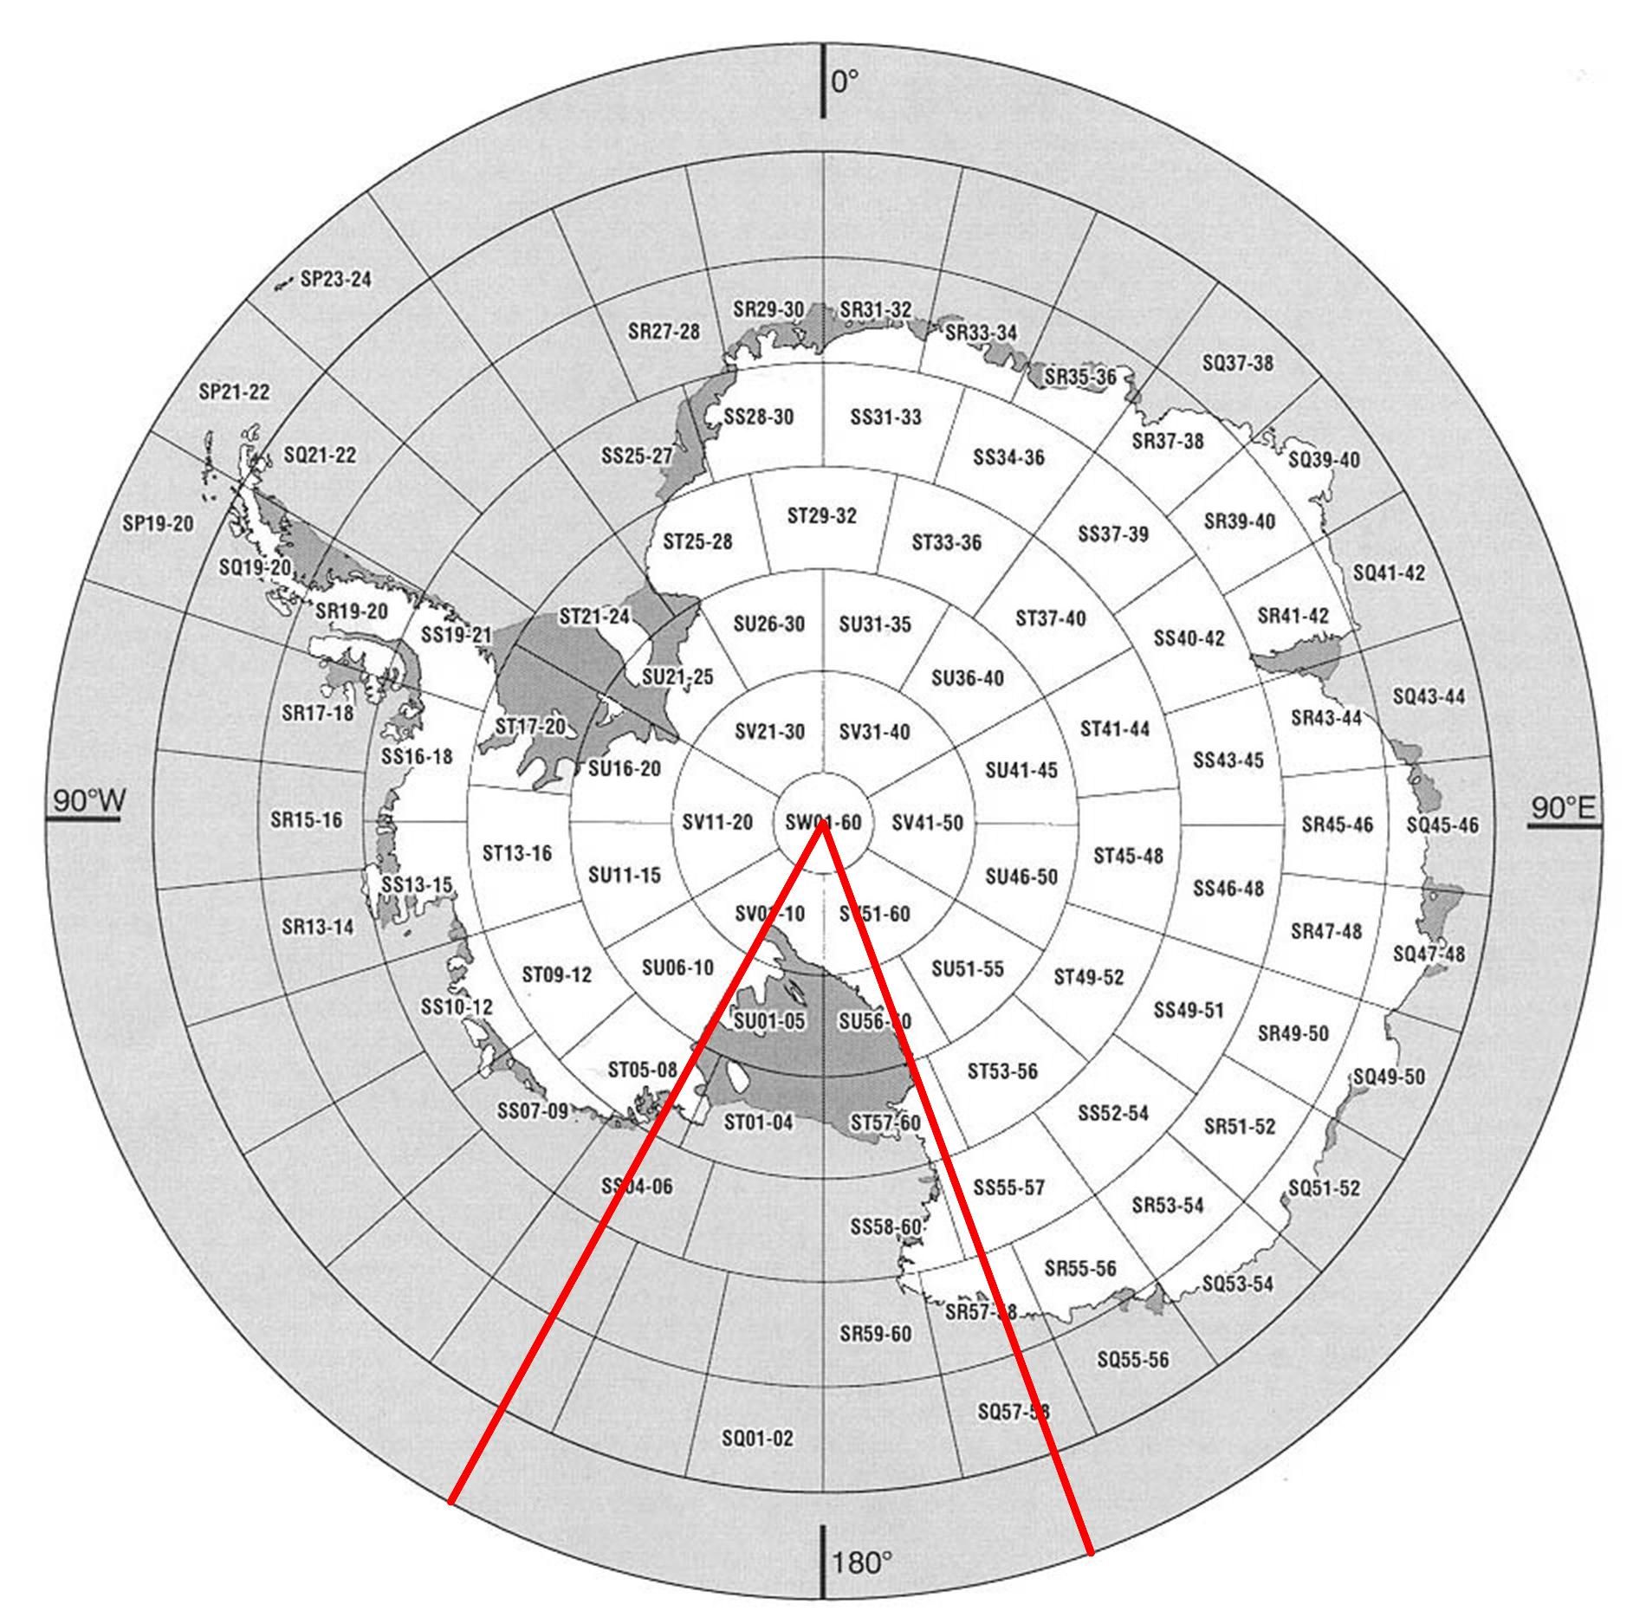
Figure 2 – IMW sheets in Antarctica, Ross Sea Region shown by red lines

Transformation Parameters
The Lambert conformal conic projection transformation parameters specified in the standard are copied from LINZS25002 Standard for NZGD2000 Projections. These parameters are based on the EPSG Lambert Conic Conformal (2SP) transformation. This transformation is equivalent to the EPSG coordinate operation 9802.
The polar stereographic projection transformation parameters specified in the standard are based on the EPSG Polar Stereographic (Variant A) transformation. This transformation is for projections that define a natural origin scale (as opposed to a standard parallel). The transformation is equivalent to the EPSG coordinate operation 9810.

Ross Sea Region Projections

Introduction
The four projections shown in Figure 3 have been developed to provide a consistent method of representing geospatial data throughout the Ross Sea Region in terms of the RSRGD2000. Each projection is discussed in the following sections.
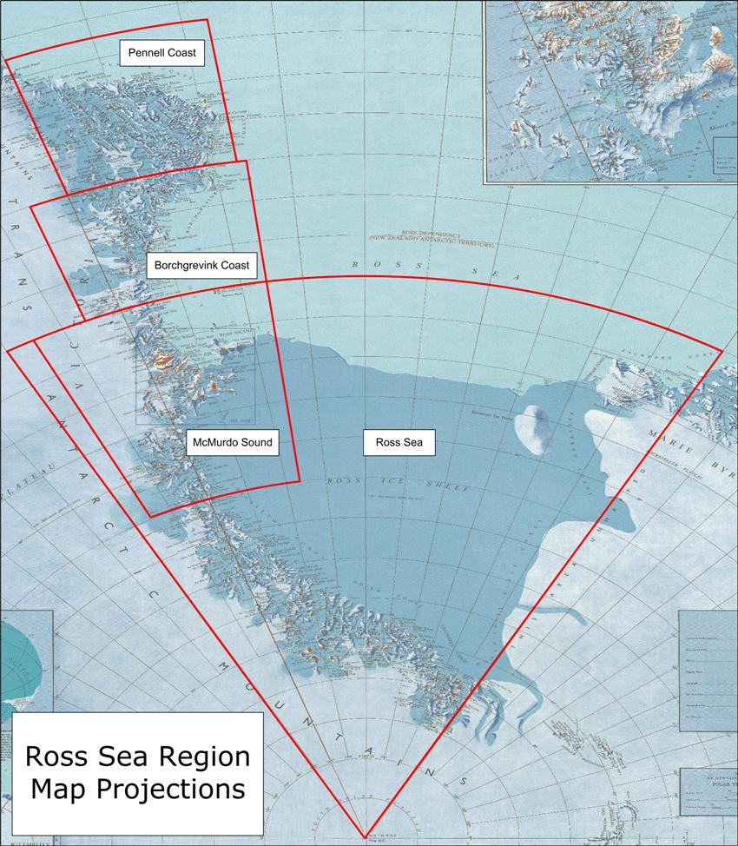
Figure 3 – Ross Sea Region Map Projections

McMurdo Sound Lambert Conformal 2000
The McMurdo Sound Lambert Conformal 2000 (MSLC2000) projection addresses the problem of large distortions incurred by the DGLC2000 on Ross Island by moving the projection 6° to the west (i.e. changing the central meridian from 157° E to 163° E). The latitudes of two standard parallels have been retained. This produces a Lambert Conformal Conic projection that is roughly centred along the axis of the Trans-Antarctic Mountains where the majority of the New Zealand based Antarctic research is undertaken.
This ensures that it will be a practical projection for the representation of spatial data. Both Ross Island and the Darwin Glacier are comfortably contained within the projection extents. As such, it is recommended that the LINZ produced Darwin Glacier mapping should be produced in terms of the MSLC2000 and the DGLC2000 be withdrawn.
The MSLC2000 is consistent with IMW series as it uses the same standard parallels as the ST sheet band. It differs in that the longitude origin is centred on the Trans-Antarctic Mountains and the southern extent is 1° further south to include the Darwin Glacier area.

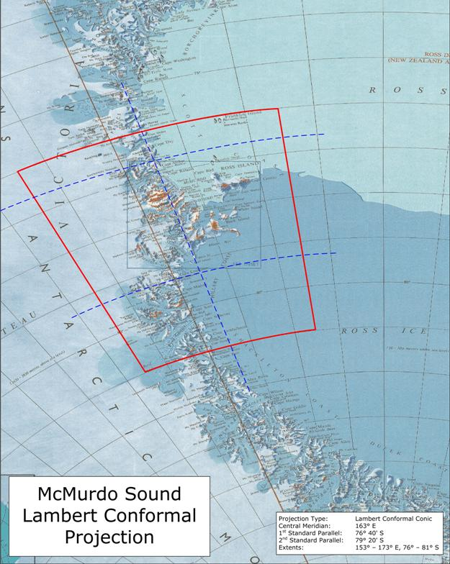
Figure 4 – McMurdo Sound Lambert Conformal 2000

Borchgrevink Coast Lambert Conformal 2000
The Borchgrevink Coast Lambert Conformal 2000 (BCLC2000) projection covers the 3° band immediately to the north of the MSLC2000 extent. While there is relatively little New Zealand supported scientific activity in this area, the Italian Terra Nova Bay base is sited in the centre of the coverage.
The BCLC2000 is consistent with IMW series as it uses the same standard parallels as the SS sheet band. It differs in that the longitude origin is centred to provide coverage of the coastal and mountainous topography in this area.

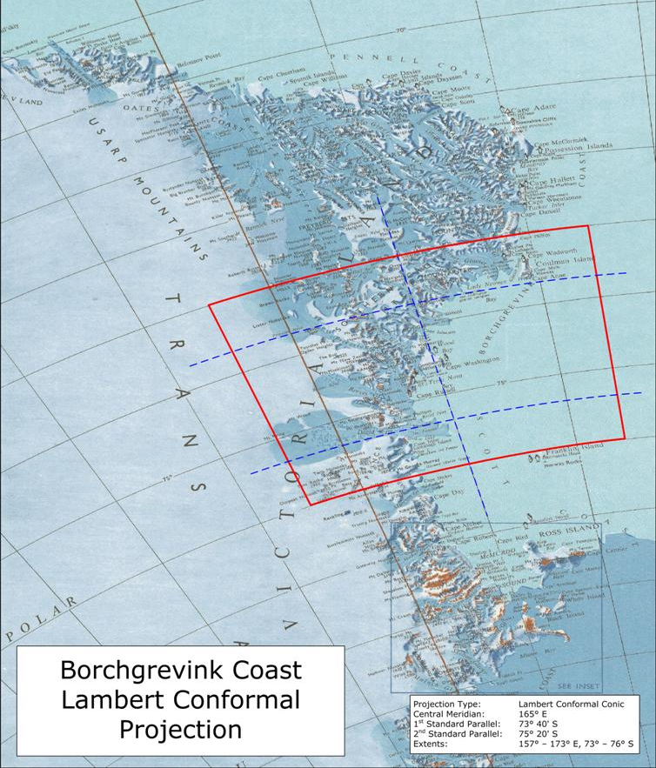
Figure 5 – Borchgrevink Coast Lambert Conformal 2000

Pennell Coast Lambert Conformal 2000
The Pennell Coast Lambert Conformal 2000 (PCLC2000) projection covers the northern area of the Ross Sea Region. The north-eastern coast of Victoria Land is a frequent destination for cruise ships.
The PCLC2000 is consistent with IMW series as it uses the same standard parallels as the SR sheet band. It differs in that the longitude origin is centred to provide coverage of the coastal and mountainous topography in this area and the northern extent is 30’ further north to include Belousov Point.

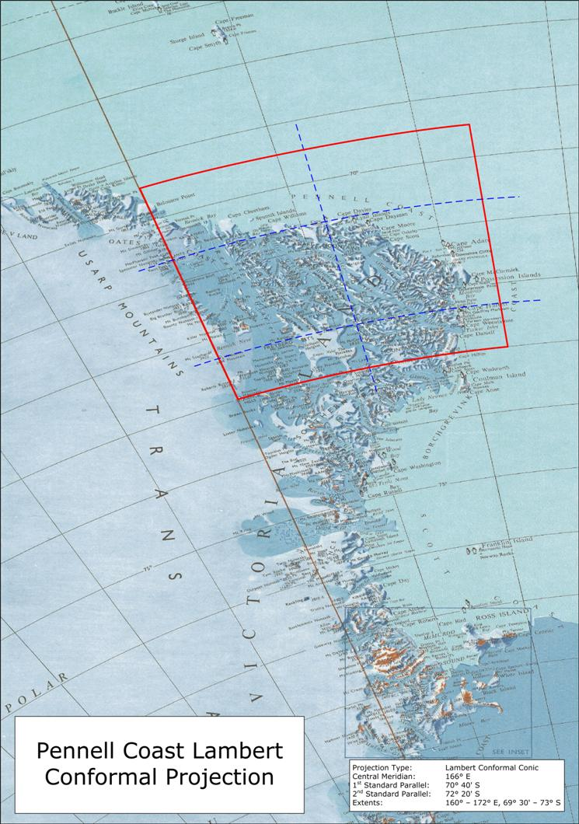
Figure 6 – Pennell Coast Lambert Conformal 2000

Ross Sea Polar Stereographic 2000
The Ross Sea Polar Stereographic 2000 (RSPS2000) projection covers the remainder of the land within Ross Sea Region, and incorporates the permanent Ross Ice Shelf. It includes the area covered by the MSLC2000. This is to enable the RSPS2000 extent to be defined as a simple sector. While there is little scientific activity in much of the RSPS2000 area, the projection has been defined to ensure a consistent system is available throughout the Ross Sea Region.
The northern extent of the projection is 76° S to ensure that the Edward VII Peninsula is included. The RSPS2000 origin scale factor is equal to that used in the UPS South projection. The major difference between the two projections is that the RSPS2000 has a longitude origin of 180° (instead of 0°) so that coordinates get larger when travelling north within the Ross Sea Region. The RSPS2000 also provides easting/northing values that are unique and which are always positive throughout the Ross Sea Region.

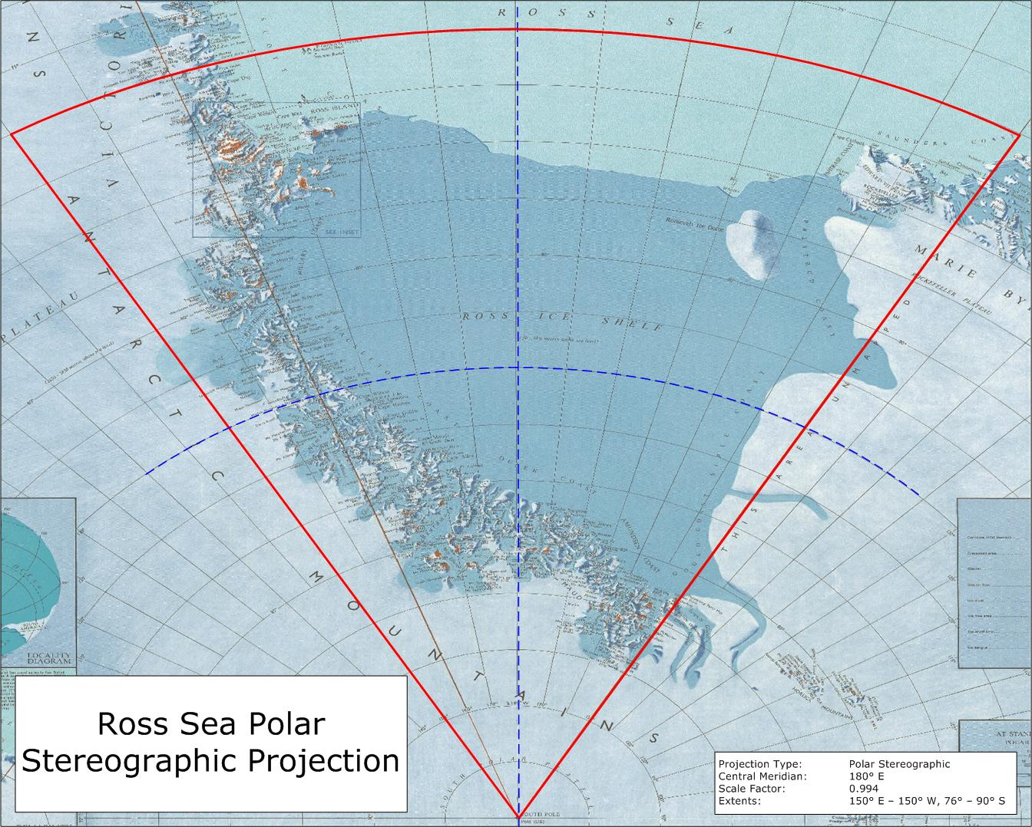
Figure 7 – Ross Sea Polar Stereographic 2000

LINZ 2008, LINZS25007 Standard for Darwin Glacier Lambert Conformal 2000 Projection, Office of the Surveyor-General, Land Information New Zealand, Wellington, 2 pp
http://en.wikipedia.org/wiki/Universal_Transverse_Mercator_coordinate_system
http://en.wikipedia.org/wiki/Universal_Polar_Stereographic
DMA (1989) The Universal Grids: Universal Transverse Mercator (UTM) and Universal Polar Stereographic (UPS), Defense Mapping Agency Technical Manual 8358.2, September 1989, 49 pp
http://en.wikipedia.org/wiki/Military_grid_reference_system
Sievers J, Bennat H (1989) Reference systems of maps and geographic information systems of Antarctica, Antarctic Science 1(4), pp 351-362
SCAR (1989) Meeting of SCAR Working Group on Geodesy and Cartography: Summary Report (12-16 September 1988), SCAR Bulletin No 92, January 1989, pp 11-12
http://nsidc.org/data/radarsat/images/ramp_basics/antmap.jpg
LINZ (2007) LINZS25002 Standard for New Zealand Geodetic Datum 2000 Projections Version 2, Land Information New Zealand, Wellington, 21 pp
OGP (2007) Coordinate Conversions and Transformations including Formulas, Guidance Note Number 7 Part 2, International Association of Oil and Gas Producers, pp 20-22, available from: http://www.epsg.org/guides/G7-2.html
OGP (2007) Coordinate Conversions and Transformations including Formulas, Guidance Note Number 7 Part 2, International Association of Oil and Gas Producers, pp 50-55, available from: http://www.epsg.org/guides/G7-2.html

