Ross Sea Region Geodetic Datum 2000
LINZG25701
This fact sheet describes the
Ross Sea Region Geodetic Datum 2000 (RSRGD2000)
Further information
LINZ standards, fact sheets, and up-to-date information are available on the LINZ website: http://www.linz.govt.nz.
Further information is available from:
Surveyor-General
Land Information New Zealand
PO Box 5501
Lambton Quay
Wellington 6145
Email: info@linz.govt.nz
LINZ has published a new geodetic datum for the Ross Sea Region of Antarctica - the Ross Sea Region Geodetic Datum 2000 (RSRGD2000).
RSRGD2000 is the official geodetic datum that provides an accurate and consistent system for the spatial referencing of points and objects within the Ross Sea Region of Antarctica.
The Ross Sea Region is the sector of Antarctica south of 60° and bounded by 160° East and 150° West. The region broadly covers the Ross Sea and the Ross Ice Shelf and extends to the South Pole.
A datum is a mathematically defined reference surface, approximating the shape of the Earth, that enables calculations such as “position” and “area” to be carried out consistently and accurately.
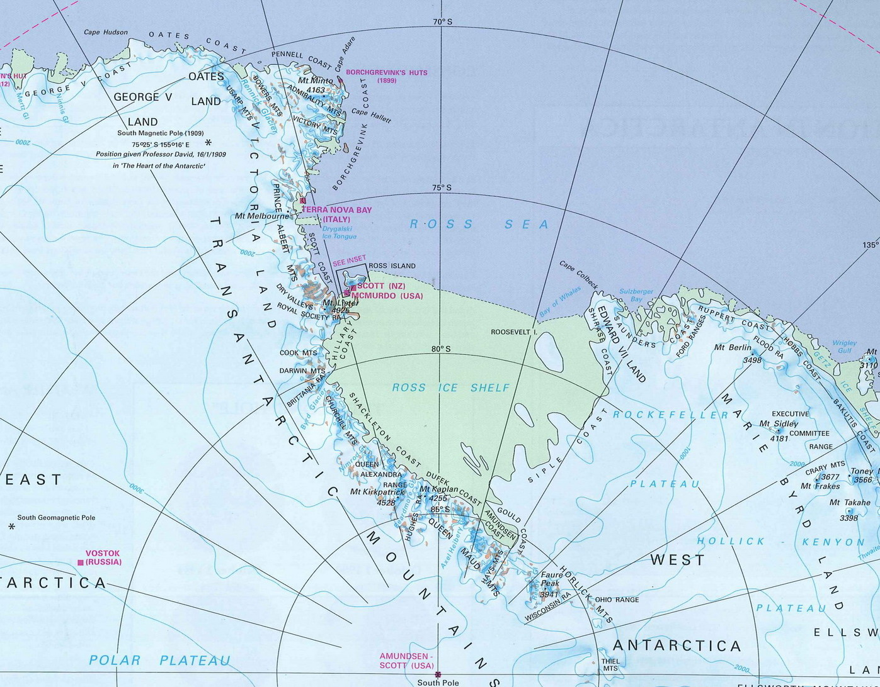
The datum is physically represented by a framework of ground monuments, such as trig stations. The positions of these monuments have been accurately measured and calculated on this reference surface. Due to the large size and sparse population of the Ross Sea Region, the monuments have been placed only in areas of topographic mapping and scientific research.
Features of RSRGD2000
- It is geocentric and compatible with satellite positioning systems.
- It is based on, and aligned with, the International Terrestrial Reference Frame 1996 (ITRF96) and uses the Geodetic Reference System 1980 (GRS80) ellipsoid.
- RSRGD2000 coordinates are specified at 1 January 2000.
- Transformations to previous datums need to be determined on a case-by-case basis.

