Datum and Projection Transformations
LINZG25703: Version 2
This fact sheet explains how to convert geographic coordinates to and from the Transverse Mercator and Lambert Conformal Conic projections
Further information
LINZ standards, fact sheets and up-to-date information are available on the LINZ website: http://www.linz.govt.nz.
Further information is available from:
Surveyor-General
Land Information New Zealand
PO Box 5501
Lambton Quay
Wellington 6145
Email: info@linz.govt.nz
Before different geospatial datasets can be combined they need to be in terms of the same datum and projection
Official transformations are defined in two LINZ standards: LINZS25000 Standard for New Zealand Geodetic Datum 2000 and LINZS25002 Standard for New Zealand Geodetic Datum 2000 Projections: Version 2.
This fact sheet describes how to apply these standards to transform coordinates between different geodetic datums and projections.
Coordinate transformations
The procedure to transform coordinates from one projection to another is shown in the diagram below. In general, a projected coordinate first needs to be “de-projected” to a geographic coordinate in terms of its geodetic datum. It can then be re-projected onto the new projection if it is in terms of the same datum. If the new projection is in terms of a different datum, the geographic coordinate should be converted to the new datum before it is then re-projected.
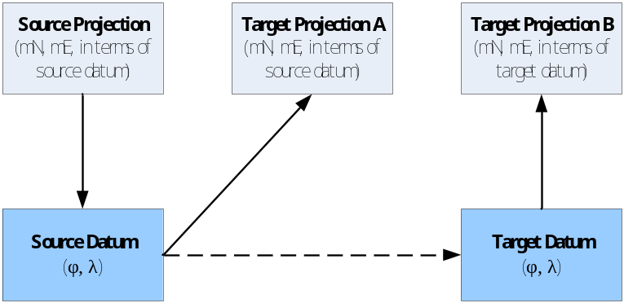
This fact sheet also describes the process and formulas for transforming Transverse Mercator and Lambert Conformal Conic projection coordinates to and from their geodetic datum (geographic) equivalents. It also shows how to convert coordinates between geodetic datums using Cartesian transformations.
These transformations can also be carried out on the LINZ website using an online coordinate conversion utility.

Version 2 of this fact sheet incorporates a sign change in Term 4 of the “Transverse Mercator projection to geographic” latitude computation on page 3

Transverse Mercator Transformations
This page explains how to convert Transverse Mercator projection coordinates (N, E) to their geographic equivalents and vice versa.
Projection parameters
Knowledge of the following datum and projection parameters is necessary before these formulas can be used. For NZGD2000 projections they are defined in LINZS25002.
 | Semi-major axis of reference ellipsoid
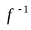 | Inverse ellipsoidal flattening
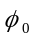 | Origin latitude
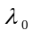 | Origin longitude
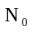 | False Northing of projection
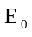 | False Easting of projection
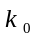 | Central meridian scale factor
 | Latitude of computation point
 | Longitude of computation point
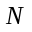 | Northing ordinate of computation point
 | Easting ordinate of computation point
Projection constants
Several additional parameters, ,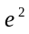,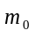, need to be computed before transformations can be undertaken. These parameters are constant for a projection.
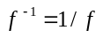
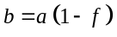
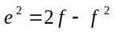
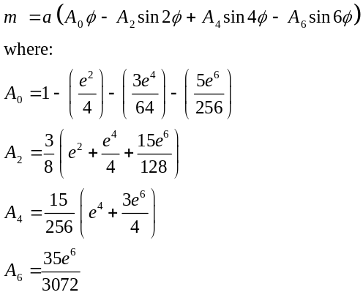
is obtained by evaluating using
Geographic to Transverse Mercator projection
The conversion of geographic coordinates (φ, λ) to projection coordinates (N, E) is achieved in several steps. These are:
Determine,,and at the computation point (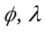):
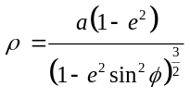
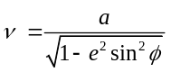
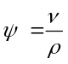
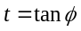
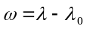
Determine the projection northing (N) of the computation point using:
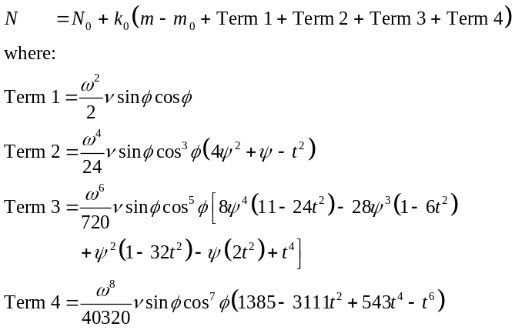
Determine the projection easting (E) of the computation point using:
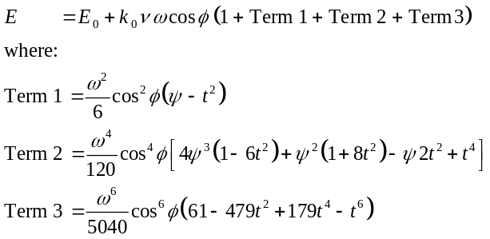

Converting NZMG coordinates to NZTM2000  Until recently most New Zealand geospatial and topographic data was held in terms of the NZGD1949 based New Zealand Map Grid (NZMG) projection. NZMG is a conformal (orthomorphic) projection that is unique to New Zealand. | The three-step process to convert NZMG coordinates to the NZGD2000 based NZTM2000 projection is described on the LINZ website.  Alternatively the online or downloadable utilities (outlined in the following box) can be used to automate the process.

Transverse Mercator projection to geographic
The conversion of Transverse Mercator projection coordinates (N, E) to geographic coordinates (φ, λ) is achieved in several steps. These are:
First determine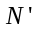,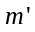,,, and using:
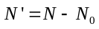
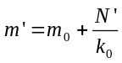
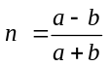
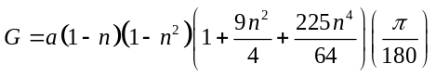
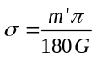
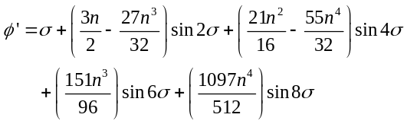
Then determine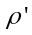,,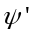,, and using:
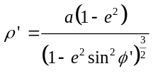
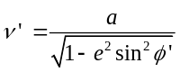
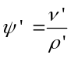
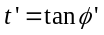
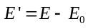
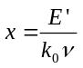

Then, compute the latitude of the computation point using:
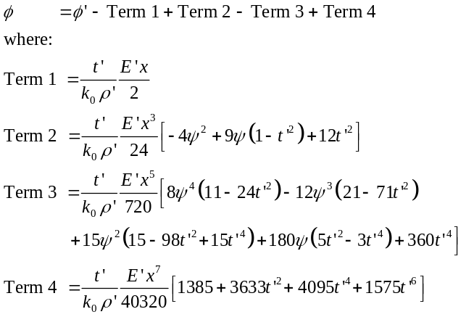
Finally, determine the longitude of the computation point using:
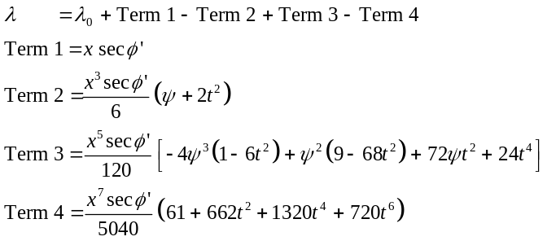
Grid convergence and point scale factor
Grid convergence () is the angle at a point between true north and grid (projection) north. The point scale factor () is the scale factor at a point that changes with increasing distance from the central meridian.
Both and can be evaluated for the coordinates in the Transverse Mercator and Lambert Conformal projections using the respective formulas defined in LINZS25002.

Convert coordinates online  All of the transformations described in this fact sheet can be carried out automatically using the online coordinate conversion utility that is available on the LINZ website.  This utility enables the user to enter coordinates in terms of the most commonly used New Zealand datums and projections and transform them to the datum and projection of their choice.  Coordinates can be entered individually or by copying large lists from other applications.  The online coordinate converter can be accessed at:  www.linz.govt.nz/apps/coordinateconversions/index.html | A stand alone software application, Concord, is also available as an alternative to converting coordinates online.  Concord is a DOS based application that completes the same conversions as the online utility. It is more suited to the conversion of large numbers of coordinates. It can also be easily customised to include additional user-defined datums and projections.  Concord can be downloaded from:  www.linz.govt.nz/downloadsoftware

Lambert Conic Conformal Transformations
This page explains how to convert Lambert conic conformal projection coordinates (N, E) to their geographic equivalents (φ, λ) and vice versa. The following formulas are for projections with two standard parallels
Projection parameters
Knowledge of the following datum and projection parameters is necessary before these formulas can be used. For NZGD2000 projections they are defined in LINZS25002.
 | Semi-major axis of reference ellipsoid
 | Inverse ellipsoidal flattening
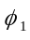 | Latitude of first standard parallel
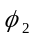 | Latitude of second standard parallel
 | Origin latitude
 | Origin longitude
 | False Northing of projection
 | False Easting of projection
 | Latitude of computation point
 | Longitude of computation point
 | Northing ordinate of computation point
 | Easting ordinate of computation point
Projection constants
Several additional parameters, ,,,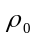, need to be computed before transformations can be undertaken. These parameters are constant for a projection.
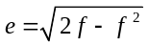
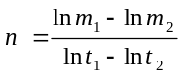
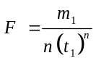
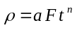
where
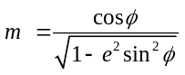
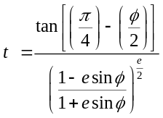
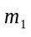 and 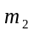 are obtained by evaluating using , and
, and are obtained by evaluating using , , and
is obtained by evaluating using
Geographic to Lambert conformal projection
The conversion of geographic coordinates (φ, λ) to projection coordinates (N, E) is achieved in several steps. First, determine and at the using the latitude of the computation point () and the formulas above. Then evaluate at the longitude of the computation point () using:
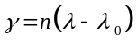
Then compute the projection northing (N) of the computation point using:
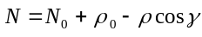
Finally, compute the projection easting (E) of the computation point using:
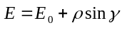

Lambert conformal projection to geographic
The conversion of Lambert projection coordinates (N, E) to geographic coordinates (φ, λ) is achieved in several steps. First, determine,,, and using the following formulas:
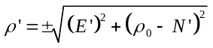 has the same sign as
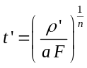
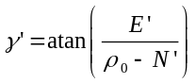
The latitude of the computation point needs to be computed iteratively. The first approximation is obtained from:
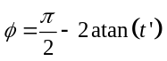
This initial estimate of is then substituted into:
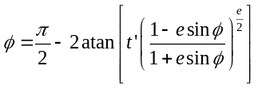
This value of should be re-substituted into the above formula until successive values do not change. This is typically achieved after three iterations.
The longitude of the computation point () is determined using:
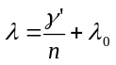
Datum Transformations
A geographic coordinate (latitude , longitude and ellipsoidal height ) is in terms of a geodetic datum (e.g., NZGD2000). The conversion of geographic coordinates between datums follows the process shown in the diagram below.
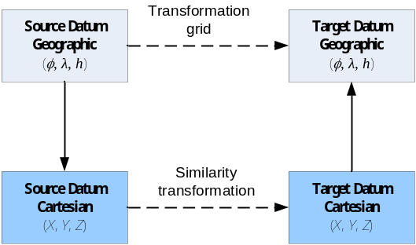
Similarity transformations
The most common method of transforming geographic coordinates is to use a similarity transformation. Similarity transformations model the differences between geodetic datums in terms of translation, rotation and scale parameters. The parameters refer to the Cartesian axes (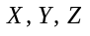) that the datums are based on. The most common transformations use three or seven parameters.
Because the transformation parameters relate to the Cartesian axes of the datum the geographic coordinates first need to be converted to their Cartesian values. The similarity transformation is then applied and the resulting Cartesian coordinates converted back to geographic positions in terms of the new geodetic datum.
Similarity transformations are three-dimensional transformations. They require the input of an ellipsoidal height for every geographic coordinate being transformed. Where ellipsoidal heights are not known for a geodetic datum such as NZGD1949, they must be estimated.
The procedure for converting geographic coordinates from datum 1 to datum 2 is described below.
Transformation parameters
 | Semi-major axis of reference ellipsoid
 | Inverse ellipsoidal flattening
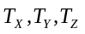 | Translation of origin along X, Y and Z axes
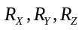 | Rotation around X, Y and Z axes (radians)
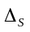 | Scale change (ppm)
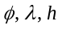 | Geographic latitude, longitude, ellipsoidal height
 | Cartesian coordinate
Geographic to Cartesian
Compute the Cartesian () values of the geographic coordinates using and from datum 1
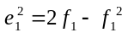
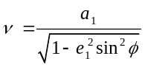
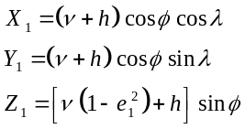
Three or seven parameter transformation
The three parameter transformation is implemented using the following equation:
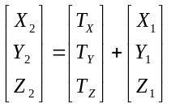
The seven parameter transformation is implemented using the following equation:
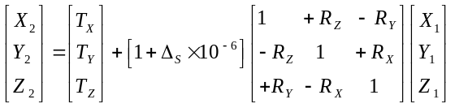
Cartesian to Geographic
The geographic coordinates in terms of datum 2 are then obtained (using and from datum 2) from:
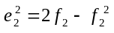
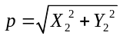
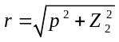
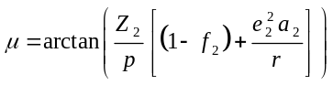
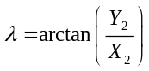
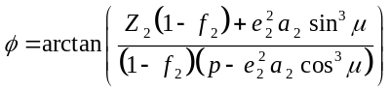
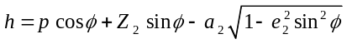
Transformation grid
An alternative method of converting coordinates is to use a transformation grid to model the difference between two geodetic datums. A grid is an array of differences between two datums in terms of geographic coordinates. It can be used to directly transform coordinates between datums.
A transformation grid to convert between the NZGD1949 and NZGD2000 datums is available on the LINZ website. In this case transformation corrections are interpolated from the grid at the NZGD1949 positions and then applied to the original coordinates.

