Standard for stopping or resumption of road
LINZS15002
22 August 2012


www.linz.govt.nz
Table of contents
Terms and definitions 1
Foreword 2
1 Scope 4
2 Intended use of standard 4
3 Road stopping 5
3.1 Introduction 5
3.2 Road stopping under the Public Works Act 1981 7
3.3 Stopping of road in a rural area under the Local Government Act 1974 9
4 Right of resumption for unformed roads 12
4.1 Introduction 12
4.2 Application to Land Information New Zealand 12
4.3 Ngāti Mutunga Protocol 13
4.4 Ngāti Tama Protocol 13
Appendix A: LINZ Protocol Area for Ngāti Mutunga 14
Appendix B: LINZ Protocol Area for Ngāti Tama 15

Terms and definitions
For the purposes of this standard, the following terms and definitions apply.
Term/abbreviation | Definition
computer register | as defined in s 4 of the Land Transfer (Computer Registers and Electronic Lodgement) Amendment Act 2002 and created by the Registrar-General of Land under ss 7 to 14 of that Act; formerly known as certificate of title
council | as defined in s 2 of the Local Government Act 1974. Has the same meaning as 'local authority'
Gazette | The New Zealand Gazette - Te Kahiti o Aotearoa, the official newspaper of the government of New Zealand
government road | as defined in s 2 of the Local Government Act 1974
LGA | Local Government Act 1974
LINZ | Land Information New Zealand
local authority | a regional council or territorial authority. Definition from s 5(1) of the Local Government Act 2002. Has the same meaning as 'council'
Minister | Minister of Lands referred to in s 4A of the Public Works Act 1981 and s 342 of the Local Government Act 1974. The statutory responsibilities of the Minister of Lands are held by the Minister for Land Information
Ngāti Mutunga Protocol | Land Information New Zealand Protocol with Ngāti Mutunga, entered into under the Ngāti Mutunga Treaty settlement
Ngāti Tama Protocol | Land Information New Zealand Protocol with Ngāti Tama, entered into under the Ngāti Tama Treaty settlement
principal administrative officer | as defined in s 2 of the Local Government Act 1974
PWA | Public Works Act 1981
resumption | the transfer of any unformed road by a territorial authority to the Crown as provided for under s 323 of the Local Government Act 1974
road | as defined in s 315 of the Local Government Act 1974 and s 43(1) of the Government Roading Powers Act 1989, and includes part of a road
rural area | as defined in s 2 of the Local Government Act 1974
territorial authority | a city council or a district council named in Part 2 of Schedule 2 of the Local Government Act 2002. Definition from s 5(1) of the Local Government Act 2002

Foreword

Introduction
- The Public Works Act 1981 (PWA) and the Local Government Act 1974 (LGA) set out procedures for stopping of land that has the status of road, and the LGA also sets out procedures for any resuming of land that has the status of road. The Crown must use the provisions of the PWA to stop roads. Local authorities may use the provisions of the LGA or request the Minister use the provisions of the PWA to stop roads.
- LINZ has entered into Protocols with Ngāti Mutunga and Ngāti Tama under the Crown Deeds of Settlement with those iwi. Consultation is required with Ngāti Mutunga and Ngāti Tama if there is a proposal to resume an unformed road that is situated in areas covered by the respective protocols.
- Disposal of land that is stopped road must be carried out in accordance with the relevant statutory provisions in the PWA or the LGA.
- Disposal of land that is resumed road must be carried out in accordance with the relevant statutory provisions in the Land Act 1948.

Purpose of standard
The purpose of this standard is to ensure that the Minister’s role in road stopping or resumption is correctly carried out and that, where applicable, the protocols the Crown has with Ngāti Mutunga and Ngāti Tama are followed where it is proposed to resume an unformed road.

Superseded documents
This standard supersedes the following documents:
LINZ 2004, Legalisation: Accredited Supplier Standard 16, (as amended), Property Regulatory Group, LINZ, Wellington
LINZ 2005, Disposal of Land: Accredited Supplier Standard 3, Property Regulatory Group, LINZ, Wellington
Clause 33.6 of LINZ 2005, LINZS2001: Guidelines to the Standard for the Acquisition of Land under the Public Works Act 1981, Property Regulatory Group, LINZ, Wellington
LINZ 2008, LINZS45001: Amendment to Accredited Supplier Standard 16 – Legalisation (Ngāti Tama and Ngāti Mutunga Settlement), Property Regulatory Group, LINZ, Wellington
LINZ 2009, LINZS15002: Interim standard for stopping or resumption of road, Crown Property Regulatory Group, LINZ, Wellington
References
The following documents are necessary for the application of this standard:
- Government Roading Powers Act 1989
- Land Act 1948
- Local Government Act 1974
- Ngāti Mutunga Deed of Settlement
- Ngāti Tama Deed of Settlement
- Public Works Act 1981

Scope
- This standard sets out the procedures to be followed, and provides guidance for:
  - the stopping of road under the PWA and the LGA,
  - the resumption of unformed road by the Crown from territorial authorities under the s 323 of the LGA, and
  - the resumption of unformed road in the Ngāti Tama and Ngāti Mutunga protocol areas.
- A local authority is responsible for complying with all requirements of Schedule 10 of the LGA, including public notice. This standard does not cover those requirements.

Intended use of standard
- A local authority, the NZ Transport Agency, and any Government agency or their contractor must use this standard when seeking a decision from the Minister or Land Information New Zealand (LINZ) on the stopping and resuming of road.
- All decision making powers of the Minister relating to road stopping and resumption have been delegated to the Chief Executive of LINZ. Accordingly, all references to the Minister in this document mean LINZ, with the effect that all applications under this standard must be made to LINZ.
.

Road stopping

Introduction
The provisions for stopping road under the PWA and the LGA are as follows:
- The Minister may declare any road to be stopped under s 116 of the PWA.
- A council may stop any road under s 342 of the LGA, but may not proceed to stop any road in a rural area without the prior consent of the Minister.

Guidance on mechanisms for stopping roads
Formed and unformed roads | The road stopping provisions under s 116 of the PWA and s 342 of the LGA apply to land which has the status of road, regardless of whether the road is formed or unformed.
Public Works Act 1981
Legislation | Section 116 of the PWA provides for the stopping of a road.
Use of s 116 PWA | Section 116 of the PWA is used when the NZ Transport Agency or another government agency proposes to stop a government road.  In addition, a local authority may make application to the Minister to stop a road under s 116 of the PWA.
Justification | Where a local authority makes application to the Minister to use s 116 of the PWA to stop a road it is to provide the Minister with reasons why it considers use of s 116 of the PWA is more appropriate than s 342 of the LGA.  The decision whether to stop a road under s116 of the PWA is for the Minister.
Local Government Act 1974
Legislation | Sections 319 and 342, and Schedule 10 of the LGA.  Section 342 of the LGA provides for the stopping of road.
When to use | LINZ prefers that, in the first instance, local authorities apply the procedures in s 342 of the LGA, given the requirements for public notification.  Road should be stopped using the LGA when there are likely to be objections to the proposal, or matters of public access to consider.

Road stopping under the Public Works Act 1981
When applying to the Minister to declare a road to be stopped under s 116 of the PWA, the application must include the following:
- a report with a full description of the road to be stopped, and advice on the following matters, where applicable:
  - whether the road to be stopped is a road, service lane, or access way,
  - current and potential public use of the road proposed to be stopped, including use by landowners having legal access to the road,
  - public use of any land served by the road,
  - reasons for stopping the road, and
  - proposals for the land following the road stopping;
- a copy of the approved survey plan;
- a plan or plans showing:
  - the boundaries of the road that is proposed to be stopped,
  - topographic information for the road and adjoining land, and
  - the wider area and depicting the road that is proposed to be stopped, and any alternative legal and practicable access to the land adjoining the road proposed to be stopped;
- aerial photographs outlining the road proposed to be stopped and identifying any structures on, or encroaching on, the road;
- evidence that adequate legal and practicable access to land adjoining or having legal access to the road proposed to be stopped is left or provided;
- evidence that notice has been given under s 116(2)(a) of the PWA;
- a copy of any consent required under s 116(2) of the PWA;
- a draft Gazette notice for execution;
- copies of the relevant computer registers.

Guidance on consents to stopping under the Public Works Act 1981
Legislation | Section 116 of the PWA sets out the notice, situation, and consent requirements to be met before the Minister may declare a road to be stopped.
Consent of adjoining owner | Under s 116(2)(b)(i) of the PWA, the consent of the adjoining owner is not required when adequate road access is left or provided. Adequate access should include both legal and practicable access to the adjoining land.  It may be prudent to obtain consent as it provides evidence that the adjoining owner has agreed to any exchange.
Form of consent | The consent of a local authority under s 116(2)(d) of the PWA should be signed by the principal administrative officer.

Guidance on road disposal under the Public Works Act 1981
Legislation | The key provisions relating to disposal of stopped roads are set out in Part 8 of the PWA.
Agreements for sale and purchase | Agreements for sale of land that is stopped road under s 117 of the PWA should not be entered into before the Minister’s approval under s 116 of the PWA, unless the agreement is made subject to that statutory approval being obtained.

Stopping of road in a rural area under the Local Government Act 1974
Where consent from the Minister is required to stop any road in a rural area under s 342 of the LGA, the application must include the following:
- a full description of the road;
- a report with advice on:
  - whether the road to be stopped is a road, service lane, or access way,
  - current and potential public use of the road proposed to be stopped, including use by landowners having legal access to the road,
  - public use of any land served by the road,
  - reasons for stopping the road, and
  - proposals for the land following the stopping;
- a copy of:
  - the approved survey plan referred to in clause 2 of Schedule 10 of the LGA, or
  - a plan which shows the proposed road stopping if a survey is yet to be completed;
- a plan or plans showing:
  - the boundaries of the road that is proposed to be stopped,
  - topographic information for the road and adjoining land, and
  - the wider area and depicting the road that is proposed to be stopped, and any alternative legal and practicable access to the land adjoining the road proposed to be stopped;
- aerial photographs outlining the road proposed to be stopped and identifying any structures on or encroaching on the road;
- evidence that adequate legal and practicable access to land adjoining or having legal access to the road proposed to be stopped is left or provided;
- a letter from the council requesting consent to the stopping;
- a draft consent notice for execution. This notice must contain the following:
  - the name of the road,
  - the name of the territorial authority district,
  - the name of the land registration district the land is located in,
  - a description of the road, including:
- the land area in hectares, and
- the legal description of any land the road adjoins or passes through;
  - space for a date and signature, and
  - a file reference.

Guidance on stopping of road in a rural area under the Local Government Act 1974
Legislation | Sections 319(h) and 342 of the LGA provide for a local authority to stop any road, in the manner provided in Schedule 10 to that Act.
Minister’s consent required | If a road is in a rural area, the local authority is required to obtain prior consent of the Minister under s 342(1)(a) of the LGA before proceeding to stop that road.  The Minister’s consent should be obtained before public notice of the proposed road stopping is given under clause 2 of Schedule 10 of the LGA.  The local authority is responsible for complying with all requirements of Schedule 10 of the LGA, including public notice.
Updating of cadastre | Noted that under clause 9 of Schedule 10 of the LGA a road stopping does not take effect until LINZ makes a record in the cadastre following notification by the local authority.

Right of resumption for unformed roads

Introduction
The Chief of Executive of LINZ has the delegated authority of the Minister to issue a notice under s 323 of the LGA.

Application to Land Information New Zealand
Where it is proposed to transfer to the Crown under s 323 of the LGA, any land that comprises an unformed road, the application to LINZ requesting the issue of a notice requiring that transfer must include:
- a plan showing the location and area of the unformed road,
- an explanation of the reason for the application to resume the road,
- details of any alternative access to adjoining land that is intended to be provided,
- whether the road resumption will deny or restrict access to other areas, including bush, river, or sea,
- details of the intended recipient of the land once the land has been resumed by the Crown and is disposed of,
- evidence of discussions with the council, and its response,
- comment on the current use of the unformed road,
- evidence of discussions with adjoining landowners,
- confirmation that the LINZ protocols with Ngāti Mutunga and Ngāti Tama have been considered, and complied with if applicable,
- details of any other matter that may be of consequence to the proposal, and
- a draft Gazette notice for execution.

Guidance on dealing with resumed roads
Legislation | The Land Act 1948 sets out the key provisions relating to the alienation of Crown land.
Resumed road becomes Crown land | Where the Minister requires the resumption of a road under s 323 of the LGA, the land ceases to be a road and shall be deemed to be Crown land subject to the Land Act 1948. Alienation of any such land will be under the relevant statutory provisions of the Land Act 1948.

Ngāti Mutunga Protocol
- Where the resumption of unformed road is proposed within the LINZ Protocol Area, depicted in Appendix A, the Ngāti Mutunga Governance Entity must be consulted with in terms of the principles set out in the Ngāti Mutunga Protocol.
- The Ngāti Mutunga Governance Entity must be provided with the information set out in subsection 4.2 above, and their views on the proposal sought, ensuring that the information requirements set out in the Ngāti Mutunga Protocol are met.
- The unformed road must not be resumed unless LINZ is satisfied that the Ngāti Mutunga Governance Entity has been consulted.
- Any submission on the proposal provided by Ngāti Mutunga must be submitted to LINZ with the application to transfer the land under s 323 of the LGA, and the information in paragraph 4.2.

Ngāti Tama Protocol
- Where the resumption of unformed road is proposed within the LINZ Protocol Area, depicted in Appendix B, the Ngāti Tama Governance Entity must be consulted with in terms of the principles set out in the Ngāti Tama Protocol.
- The Ngāti Tama Governance Entity must be provided with the information set out in 4.2, and their views on the proposal sought, ensuring that the information requirements set out in the Ngāti Tama Protocol are met.
- The unformed road must not be resumed unless LINZ is satisfied that the Ngāti Tama Governance Entity has been consulted.
- Any submission on the proposal provided by Ngāti Tama must be submitted to LINZ with the application to transfer the land under s 323 of the LGA, and the information in paragraph 4.2.

Appendix A: LINZ Protocol Area for Ngāti Mutunga
The LINZ Protocol Area for Ngāti Mutunga is set out in the Ngāti Mutunga Deed of Settlement, and depicted in Figure 1.
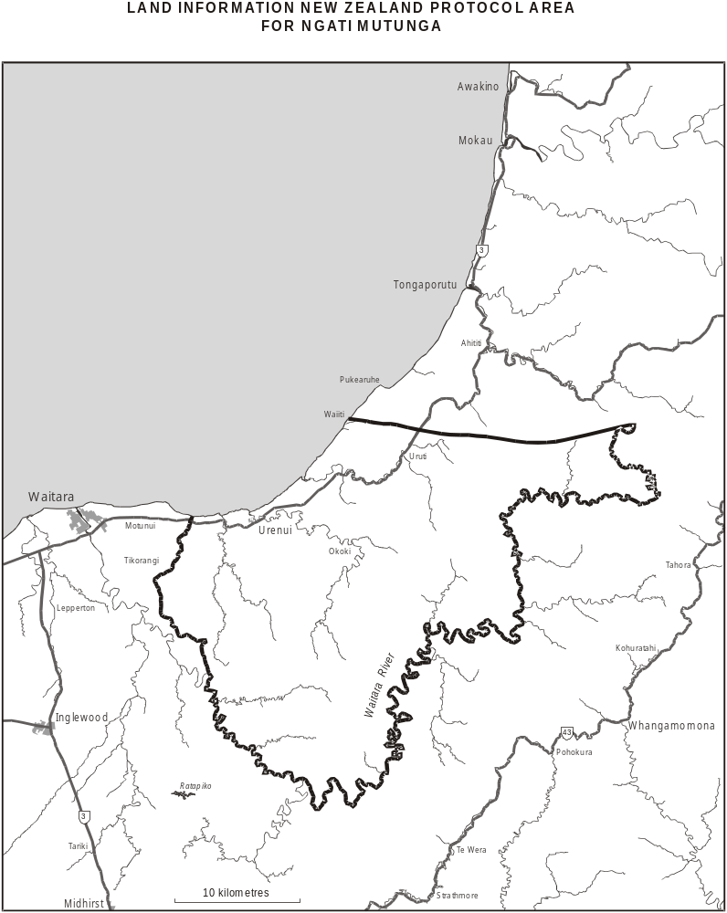Figure 1 LINZ Protocol Area for Ngāti Mutunga
Appendix B: LINZ Protocol Area for Ngāti Tama
The LINZ Protocol Area for Ngāti Tama is set out in Figure 2.
Figure 2: LINZ Protocol Area for Ngāti Tama
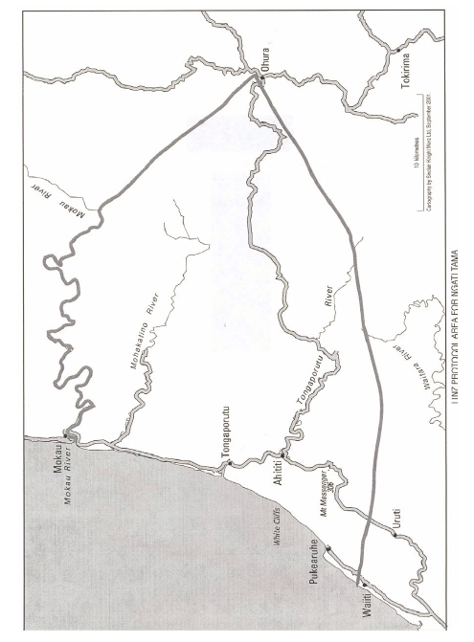

A road need not necessarily be formed or maintained: Hayes, B.E. 2007, Roading law as it applies to unformed roads, Walking Access Consultation Panel, Ministry of Agriculture and Forestry, Wellington, available at: http://www.walkingaccess.co.nz/store/doc/roadinglawapplicabletounformedroads.pdf (accessed on 14 August 2012)
The full text of the Crown Deeds of Settlement with Ngāti Mutunga and Ngāti Tama and the respective LINZ Protocols with those iwi are available from the Office of Treaty Settlements at http://www.ots.govt.nz

