


LINZS25002
Standard for New Zealand
Geodetic Datum 2000 Projections: version 2

CORRECTIONS AND AMENDMENTS

LINZS25002: Standard for New Zealand Geodetic Datum 2000 Projections: version 2, is effective from 24 July 2008 and supersedes the previous version of the standard, which was issued on 16 November 2007.

Version 2 incorporates corrections and amendments. The main changes are summarised below:
- page 5, “Terms, Definitions and Symbols”: the definitions of 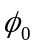 and 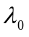 terms have been standardised
- page 10, paragraph 4(b), “New Zealand Continental Shelf Projection”: a definition of origin latitude has been added and numeric values assigned to false origins
- page 13, paragraph A.1, “Foot-point latitude”: the formula for has been generalised to enable its use with projections that do not have latitude origins on the equator
- page 14, paragraph A.2, “Latitude conversion”: the formula for 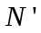 has been generalised to enable its use with projections that do not have latitude origins on the equator
- page 15, paragraph A.2, “Grid convergence”: this has been reworded to remove conflict between text and formula
- page 15 paragraph A2, “Line scale factor”: this has been reworded to improve clarity by the removal of the sentence “This will vary along the length of a line on a grid”.
- page 17, paragraph A.3, “Grid convergence”: this has been reworded to remove conflict between text and formula
- page 17 paragraph A3, “Line scale factor”: this has been reworded by the removal of the sentence “This will vary along the length of a line on a grid”to improve clarity
- page 18, Appendix B.1, “Formulas for conversion between geographic coordinates and Lambert Conformal Conic projection coordinates”: this has been replaced with a new appendix defining formulas on an ellipsoid rather than a sphere
- page 19, Appendix B.2, “Formulas for conversion from geographic coordinates to Lambert Conformal Conic projection coordinates”: this has been replaced with a new appendix defining formulas on an ellipsoid rather than a sphere
- page 20, Appendix B.3, “Formulas for conversion from Lambert Conformal Conic projection coordinates to geographic coordinates”: this has been replaced with a new appendix defining formulas on an ellipsoid rather than a sphere
Table of Contents
TERMS, DEFINITIONS AND SYMBOLS 4
FOREWORD 6
1 introduction 8
1.1 Scope 8
1.2 Intended use of standard 8
2 New zealand transverse mercator projection 2000 8
3 New zealand offshore islands transverse mercator projectionS 9
4 New zealand continental shelf projection 10
5 NZGD2000 meridional circuits 10
Appendix A 12
A.1 Formulas for conversion between geographic coordinates and Transverse Mercator projection coordinates 12
A.2 Formulas for conversion from geographic coordinates to Transverse Mercator projection coordinates 14
A.3 Formulas for conversion from Transverse Mercator projection coordinates to geographic coordinates 16
Appendix B 18
B.1 Formulas for conversion between geographic coordinates and Lambert Conformal Conic projection coordinates 18
B.2 Formulas for conversion from geographic coordinates to Lambert Conformal Conic projection coordinates 19
B.3 Formulas for conversion from Lambert Conformal Conic projection coordinates to geographic coordinates 20
TABLE
Table 1: GRS80 ellipsoid parameters (Moritz 2000) 9
Table 2: New Zealand offshore islands projection names and origin of longitude 9
Table 3: Meridional circuit projection parameters 11

TERMS, DEFINITIONS AND SYMBOLS

Term | Definition
central meridian | the line of longitude at the centre of a projection
central meridian scale factor | a multiplier applied to a projection to balance the effects of scale distortion over the coverage area of the projection
coordinate | any one of a set of numbers used in specifying the location of a point on a line, in space, or on a given plane or other surface (for example, latitudes and longitudes are coordinates of a point on the Earth’s surface)
coordinate system | a system for allocating coordinates to points in space in some specified way in relation to designated axes, planes, or surfaces. The simplest coordinate system consists of orthogonal coordinate axes, known as a Cartesian coordinate system
datum | a particular type of reference system in which coordinates are defined in relation to a particular reference surface by means of distances or angles, or both
ellipsoid | a surface formed by the rotation of an ellipse about a main axis. For the purposes of this standard, the ellipsoids used are oblate to match the general shape of the Earth. An oblate ellipsoid is one in which the semi-minor axis of the ellipse is the axis of revolution
GRS80 | Geodetic Reference System 1980 – an ellipsoid adopted by the International Association of Geodesy as the recommended best-fit ellipsoid for the Earth, Moritz (2000)
inverse flattening | the inverse of the flattening term, used by convention in ellipsoidal calculations
Lambert Conformal Conic projection | a conformal conic projection in which geographic meridians are represented by straight lines which meet at the projection of the pole and geographic parallels are represented by a series of arcs of circles with this point as their centre
NZGD2000 | New Zealand Geodetic Datum 2000
origin | the point from which the computation of a projection is evaluated
projection | a systematic method of representing the whole or part of the curved surface of the Earth upon another, usually flat, surface
semi-major axis | semi-diameter of the longest axis of an ellipsoid; this is the axis measured in the equatorial plane for an oblate ellipsoid
semi-minor axis | semi-diameter of the shortest axis of an ellipsoid, this is the axis measured through the “poles” for an oblate ellipsoid
Transverse Mercator projection | a conformal cylindrical map projection in which the surface of a sphere or ellipsoid, such as the Earth, is projected onto a cylinder tangent along a meridian.
Symbol | Definition
a | semi-major axis of reference ellipsoid
b | semi-minor axis of reference ellipsoid
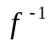 | inverse flattening of reference ellipsoid
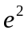 | squared-eccentricity of reference ellipsoid
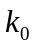 | central meridian scale factor
 | Easting ordinate of computation point
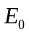 | false Easting of projection
 | Northing ordinate of computation point
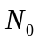 | false Northing of projection
 | latitude of computation point
 | origin latitude
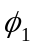 | latitude of the first standard parallel
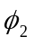 | latitude of the second standard parallel
 | longitude of computation point
 | origin longitude

FOREWORD

Section 7(1)(a) of the Cadastral Survey Act 2002 makes it a function and duty of the Surveyor-General to maintain a national geodetic system. The Surveyor-General, in agreement with the National Topographic and Hydrographic Authority, has issued this standard to meet that obligation.

Purpose of standard

The purpose of this standard is to define several map projections in terms of New Zealand Geodetic Datum 2000 (NZGD2000).

Rationale for new standard

Land Information New Zealand (LINZ) is tasked with meeting the Government’s desired economic, social, and environmental outcomes in relation to its mandated subject areas. Accordingly, end outcomes, intermediate outcomes, objectives, and sub-objectives have been developed to clearly articulate the regulatory framework for each subject area.

A risk-based approach is then used to determine the optimum level of intervention. If there is a high risk of not achieving an objective or sub-objective, then, generally, a high level of intervention is required. Similarly, a low risk of not achieving an objective or sub-objective means a low level of intervention is necessary. The desired intervention is then developed to manage the identified risks and thereby achieve the relevant sub-objectives, objectives and, therefore, the outcome.

This standard has been developed to mitigate the risk of not achieving the following end outcome and objective.

End outcome | Objective
A single common reference system that underpins the efficient operation of the cadastral, hydrography, and topography systems and meets directed government needs | Common preferred geodetic datums and projections are used by Managers of geospatial data
Brief history of standard

In 1998, LINZ introduced NZGD2000 as the official national three-dimensional geodetic datum for New Zealand. The result of changing the official New Zealand datum was that the map projections based on its predecessor (NZGD49) also needed revision. There was no previous standard for the offshore islands of New Zealand or the continental shelf.

This standard supersedes the following documents:

LINZ 1999, New Zealand Geodetic Datum 2000 Meridional Circuits, Policy 99/3, Office of the Surveyor-General, LINZ, Wellington

LINZ 1999, Chatham Island 2000 Meridional Circuit, 99/6, Office of the Surveyor-General, LINZ, Wellington

LINZ 2000, Map Projections for Cadastral Data, 2000/5, Office of the Surveyor-General, LINZ, Wellington

Committee responsible for standard

The expert committee responsible for reviewing this standard consisted of the following representatives:

Business Group (Company) | Name
Office of the Surveyor-General (LINZ) | Don Grant  Matt Amos
National Topographic and Hydrographic Authority (LINZ) | Dave Mole
Regulatory Frameworks & Processes (LINZ) | Amanda Thompson  Michelle Gooding  Ruth Willis
Customer Services (LINZ) | Graeme Blick  John Ritchie  Chris Kinzett
Antarctica New Zealand | Dean Peterson
GNS Science | John Beavan
New Zealand Cartographic Society | John Beavan
University of Otago – School of Surveying | Paul Denys

References

The following documents were used in the development of this standard:

LINZ 1999, Policy 99/3 New Zealand Geodetic Datum 2000 Meridional Circuits, Office of the Surveyor-General, LINZ, Wellington.

Moritz, H. 2000, Geodetic Reference System 1980, Journal of Geodesy, 74(1), pp.128-133.

Redfearn, J.C.B. 1948, Transverse Mercator formulae, Empire Survey Review, 69, pp. 318-322.

Robertson, W.A. 2000, Options for a new map projection in New Zealand, report to LINZ, Wellington.

introduction

A national geodetic system and its associated national survey control system are fundamental components of a nation’s infrastructure. The unique property of a geodetic system is its ability to integrate multiple geographically dependent data sources into a single geographic reference frame.

A fundamental element of a geodetic system is a national geodetic datum. To enable data collected in terms of a geodetic datum to be portrayed on a map, map projections are required.

Scope

This standard defines several map projections in terms of NZGD2000. These projections can be used for the provision and display of cadastral, topographic, and hydrographic data for New Zealand, its offshore islands, and its continental shelf.

Intended use of standard

Spatial data provided to and supplied by LINZ must comply with this standard when it is referenced by map coordinates in terms of the NZGD2000 projections.

This standard may be used by other users of spatial data. Any person claiming conformance with this standard must use the parameters defining NZGD2000 map projections as specified in this standard.

New zealand transverse mercator projection 2000
- Spatial data provided to and supplied by LINZ must conform to this standard when it is referenced by coordinates in terms of the New Zealand Transverse Mercator 2000 projection (NZTM2000).
- The NZTM2000 parameters are:
Projection name: | New Zealand Transverse Mercator 2000
Abbreviation: | NZTM2000
Projection type: | Transverse Mercator
Reference ellipsoid: | GRS80 (see Table 1)
Datum: | NZGD2000
Origin latitude: | 0° 00’ 00” South
Origin longitude: | 173° 00’ 00” East
False Northing: | 10,000,000 metres North
False Easting: | 1,600,000 metres East
Central meridian scale factor: | 0.9996
- Formulas to convert between geographic and projection (grid) coordinates are provided in Appendix A. Alternative formulas may be used but must give the same results as the formulas in Appendix A within a tolerance of 1 mm.
Table 1: GRS80 ellipsoid parameters (Moritz 2000)
Ellipsoid | Semi-major axis (metres) | Inverse flattening
GRS80 | 6378137 | 298.257222101

New zealand offshore islands transverse mercator projectionS
- Spatial data provided to and supplied by LINZ must conform to this standard when it is referenced by coordinates in terms of the New Zealand offshore islands Transverse Mercator projections listed in Table 2.
- The New Zealand offshore islands Transverse Mercator projection parameters are:
Projection name: | See Table 2
Abbreviation: | See Table 2
Projection type: | Transverse Mercator
Reference ellipsoid: | GRS80 (see Table 1)
Datum: | NZGD2000
Origin latitude: | 0° 00’ 00” South
Origin longitude: | See Table 2
False Northing: | 10,000,000 metres North
False Easting: | 3,500,000 metres East
Central meridian scale factor: | 1.0000
- Formulas to convert between geographic and projection (grid) coordinates are provided in Appendix A. Alternative formulas may be used but must give the same results as the formulas in Appendix A within a tolerance of 1 mm.
Table 2: New Zealand offshore islands projection names and origin of longitude
Area | Projection name | Abbreviation | Origin longitude
Chatham Islands | Chatham Islands Transverse Mercator 2000 | CITM2000 | 176° 30’West
Snares and Auckland Islands | Auckland Islands Transverse Mercator 2000 | AKTM2000 | 166° 00’ East
Campbell Island | Campbell Island Transverse Mercator 2000 | CATM2000 | 169° 00’ East
Antipodes and Bounty Islands | Antipodes Islands Transverse Mercator 2000 | AITM2000 | 179° 00’ East
Raoul Island and Kermadec Islands | Raoul Island Transverse Mercator 2000 | RITM2000 | 178° 00’ West

New zealand continental shelf projection
- Spatial data provided to and supplied by LINZ must conform to this standard when it is referenced by coordinates in terms of the Lambert Conformal Conic projection for the New Zealand Continental Shelf (NZCS2000).
- The NZCS2000 parameters are:
Projection name: | New Zealand Continental Shelf Lambert Conformal 2000
Abbreviation: | NZCS2000
Projection type: | Lambert Conformal Conic
Reference ellipsoid: | GRS80 (see Table 1)
Datum: | NZGD2000
First standard parallel: | 37° 30’ South
Second standard parallel: | 44° 30’ South
Origin latitude | 41° 00’ South
Origin longitude: | 173° 00’ East
False Northing: | 7,000,000 metres North
False Easting: | 3,000,000 metres East
- Formulas to convert between geographic and projection (grid) coordinates are provided in Appendix B. Alternative formulas may be used but must give the same results as the formulas in Appendix B within a tolerance of 1 mm.

NZGD2000 meridional circuits
- Spatial data provided to and supplied by LINZ must conform to this standard when it is referenced by coordinates in terms of the 28 NZGD2000 Transverse Mercator meridional circuits used for cadastral surveys in New Zealand.
- The NZGD2000 meridional circuit parameters are:
Circuit name: | See Table 3
Abbreviation: | See Table 3
Projection type: | Transverse Mercator
Reference ellipsoid: | GRS80 (See Table 1)
Datum: | New Zealand Geodetic Datum 2000
Origin latitude: | See Table 3
Origin longitude: | See Table 3
False Northing: | 800,000 metres North
False Easting: | 400,000 metres East
Central meridian scale factor: | See Table 3
Table 3: Meridional circuit projection parameters
Circuit name | Abbreviation | Origin latitude | Origin longitude | Central meridian scale factor
Mount Eden 2000 | EDENTM2000 | 36° 52’ 47” S | 174° 45’ 51” E | 0.9999
Bay of Plenty 2000 | PLENTM2000 | 37° 45’ 40” S | 176° 27’ 58” E | 1.00000
Poverty Bay 2000 | POVETM2000 | 38° 37’ 28” S | 177° 53’ 08” E | 1.00000
Hawkes Bay 2000 | HAWKTM2000 | 39° 39’ 03” S | 176° 40’ 25” E | 1.00000
Taranaki 2000 | TARATM2000 | 39° 08’ 08” S | 174° 13’ 40” E | 1.00000
Tuhirangi 2000 | TUHITM2000 | 39° 30’ 44” S | 175° 38’ 24” E | 1.00000
Wanganui 2000 | WANGTM2000 | 40° 14’ 31” S | 175° 29’ 17” E | 1.00000
Wairarapa 2000 | WAIRTM2000 | 40° 55’ 31” S | 175° 38’ 50” E | 1.00000
Wellington 2000 | WELLTM2000 | 41° 18’ 04” S | 174° 46’ 35” E | 1.00000
Collingwood 2000 | COLLTM2000 | 40° 42’ 53” S | 172° 40’ 19” E | 1.00000
Nelson 2000 | NELSTM2000 | 41° 16’ 28” S | 173° 17’ 57” E | 1.00000
Karamea 2000 | KARATM2000 | 41° 17’ 23” S | 172° 06’ 32” E | 1.00000
Buller 2000 | BULLTM2000 | 41° 48’ 38” S | 171° 34’ 52” E | 1.00000
Grey 2000 | GREYTM2000 | 42° 20’ 01” S | 171° 32’ 59” E | 1.00000
Amuri 2000 | AMURTM2000 | 42° 41’ 20” S | 173° 00’ 36” E | 1.00000
Marlborough 2000 | MARLTM2000 | 41° 32’ 40” S | 173° 48’ 07” E | 1.00000
Hokitika 2000 | HOKITM2000 | 42° 53’ 10” S | 170° 58’ 47” E | 1.00000
Okarito 2000 | OKARTM2000 | 43° 06’ 36” S | 170° 15’ 39” E | 1.00000
Jacksons Bay 2000 | JACKTM2000 | 43° 58’ 40” S | 168° 36’ 22” E | 1.00000
Mount Pleasant 2000 | PLEATM2000 | 43° 35’ 26” S | 172° 43’ 37” E | 1.00000
Gawler 2000 | GAWLTM2000 | 43° 44’ 55” S | 171° 21’ 38” E | 1.00000
Timaru 2000 | TIMATM2000 | 44° 24’ 07” S | 171° 03’ 26” E | 1.00000
Lindis Peak 2000 | LINDTM2000 | 44° 44’ 06” S | 169° 28’ 03” E | 1.00000
Mount Nicholas 2000 | NICHTM2000 | 45° 07’ 58” S | 168° 23’ 55” E | 1.00000
Mount York 2000 | YORKTM2000 | 45° 33’ 49” S | 167° 44’ 19” E | 1.00000
Observation Point 2000 | OBSETM2000 | 45° 48’ 58” S | 170° 37’ 42” E | 1.00000
North Taieri 2000 | TAIETM2000 | 45° 51’ 41” S | 170° 16’ 57” E | 0.99996
Bluff 2000 | BLUFTM2000 | 46° 36’ 00” S | 168° 20’ 34” E | 1.00000

Appendix A
- Formulas for conversion between geographic coordinates and Transverse Mercator projection coordinates
This section provides formulas to convert coordinates between geographic and the Transverse Mercator projection. These formulas are based on those developed by Redfearn (1948).

Preliminary calculations

These formulas are necessary for the calculations in the later sections.

Semi-minor axis of reference ellipsoid
This is derived from the semi-major axis and the flattening of the reference ellipsoid

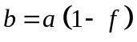

Eccentricity
This is derived from the semi-major and semi-minor axes of the reference ellipsoid:

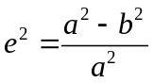

Meridian distance
The distance along the meridian from the latitude of the projection origin (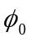) to the latitude .

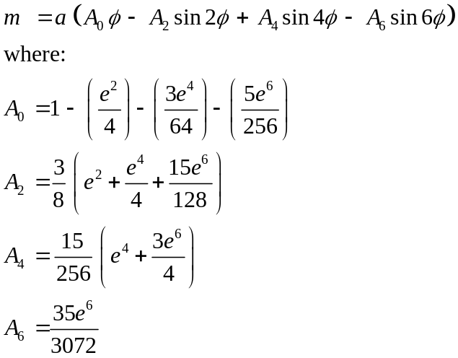

Foot-point latitude
The foot-point latitude (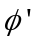) is the latitude for which the meridian distance equals the true Northing divided by the central scale factor.

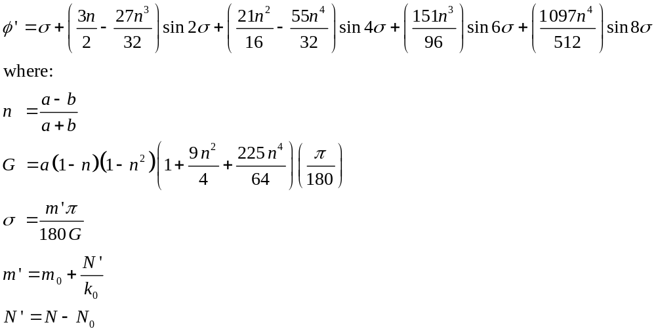
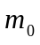 is calculated using the meridian distance formula for at the origin latitude 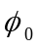.

Radius of curvature
The radius of curvature of the meridian () and radius of curvature in the prime vertical () are also required.

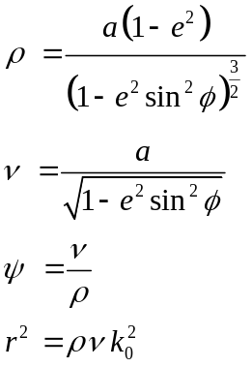

- Formulas for conversion from geographic coordinates to Transverse Mercator projection coordinates
This section provides formulas to convert geographical coordinates (eg latitude and longitude) to Transverse Mercator projection coordinates (eg Northing and Easting).

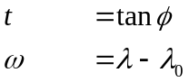

Longitude conversion

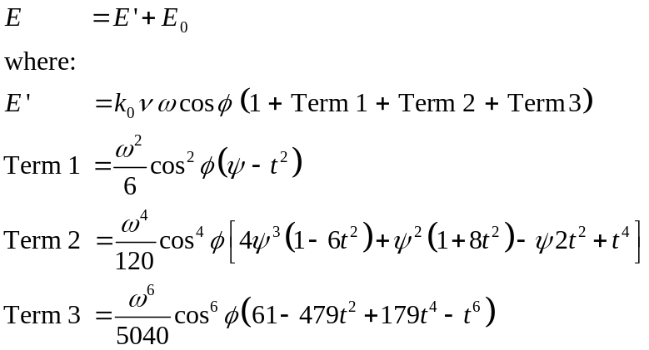

Latitude conversion

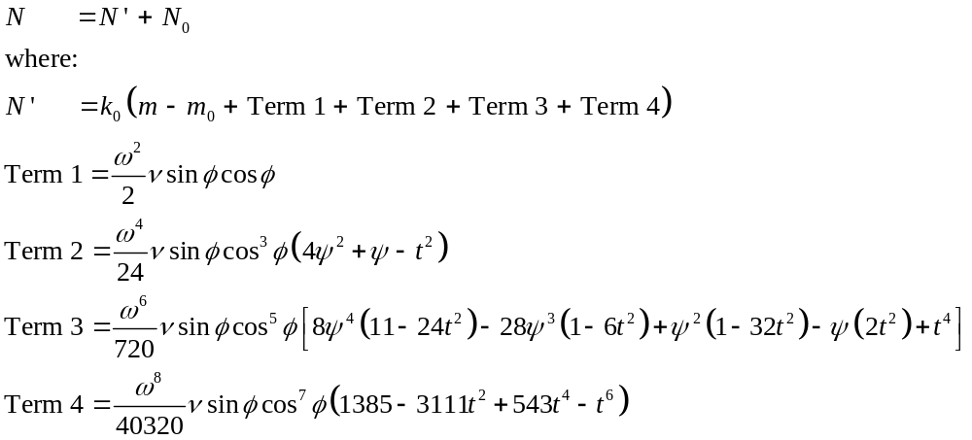

Grid convergence
Grid convergence is the angle at a point between true and grid North. It is positive when grid North lies to the West of true North.

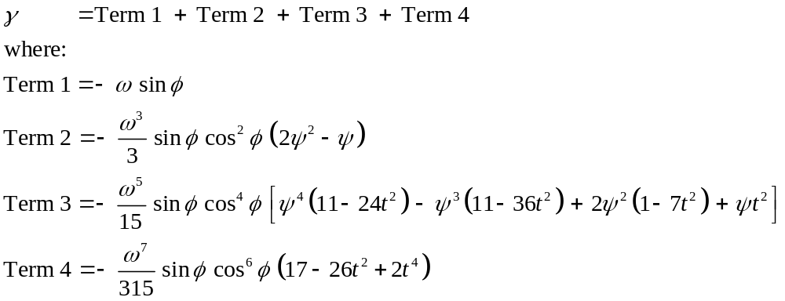

Point scale factor
The scale factor (k) at a point away from the central meridian.

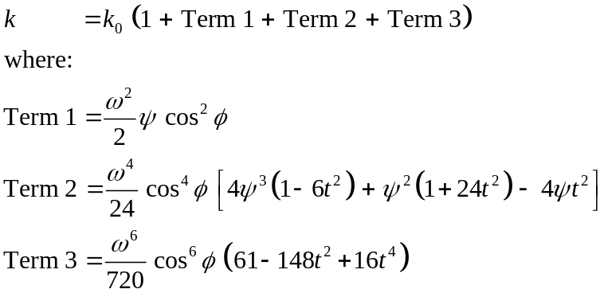

Line scale factor
The line scale factor (K) is the ratio of a plane distance to the corresponding ellipsoidal distance between points 1 and 2.

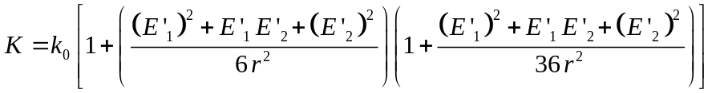

- Formulas for conversion from Transverse Mercator projection coordinates to geographic coordinates
This section provides formulas to convert Transverse Mercator projection coordinates (eg Northing and Easting) to geographical coordinates (eg latitude and longitude).

In the following formulas, , , and 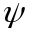 are all evaluated for the foot point latitude ().

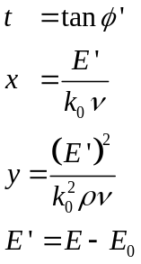

Northing conversion
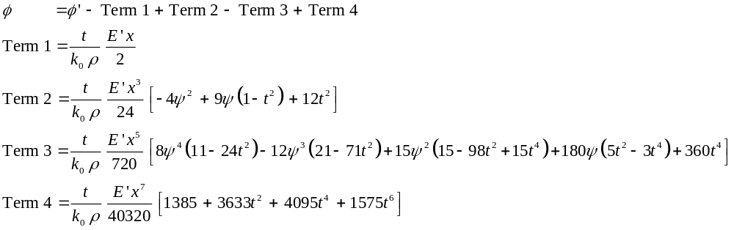

Easting conversion
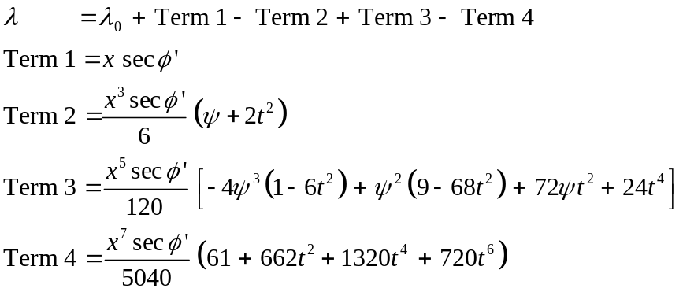

Grid convergence
Grid convergence is the angle at a point between true and grid North. It is positive when grid North lies to the West of true North.

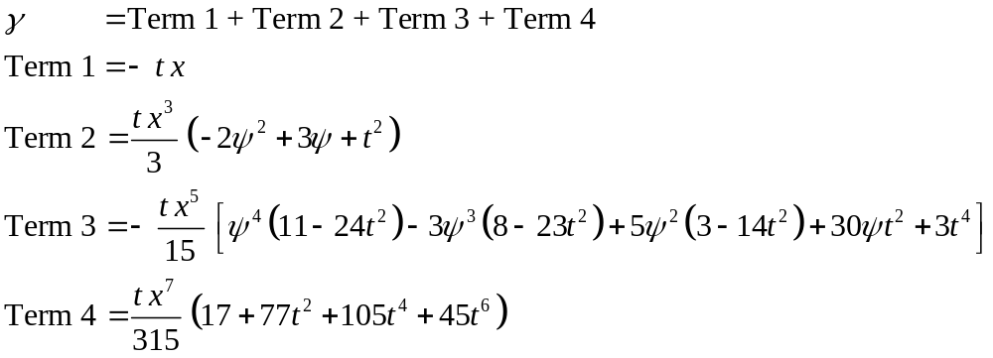

Point scale factor
The scale factor (k) at a point away from the central meridian.

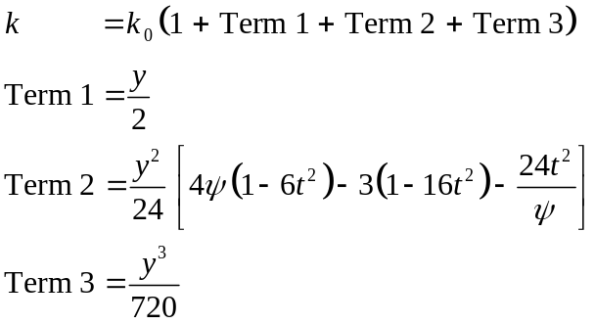

Line scale factor
The line scale factor (K) is the ratio of a plane distance to the corresponding ellipsoidal distance between points 1 and 2.

Appendix B
- Formulas for conversion between geographic coordinates and Lambert Conformal Conic projection coordinates
This section provides formulas to convert coordinates between geographic and the Lambert Conformal Conic projection.

Preliminary computations
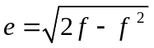
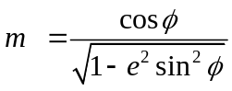 where 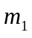 and 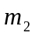 are calculated from 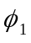 and 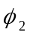
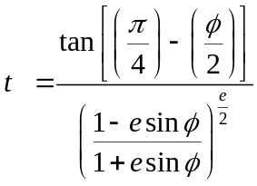 where 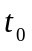, and 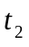 are calculated from 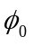, and
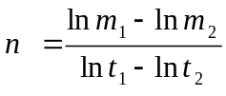
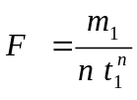
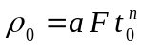

- Formulas for conversion from geographic coordinates to Lambert Conformal Conic projection coordinates
This section provides formulas to convert geographical coordinates (eg latitude and longitude) to Lambert Conformal Conic projection coordinates (eg Northing and Easting).

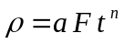

Grid convergence
Grid convergence is the angle at a point between true and grid North. It is positive when grid North lies to the West of true North.
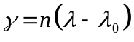

Longitude conversion
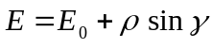

Latitude conversion
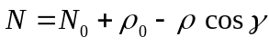

Point scale factor
The scale factor (k) is calculated at a point away from the standard parallels.
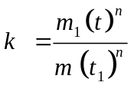

- Formulas for conversion from Lambert Conformal Conic projection coordinates to geographic coordinates
This section provides formulas to convert Lambert Conformal Conic projection coordinates (eg Northing and Easting) to geographical coordinates (eg latitude and longitude).

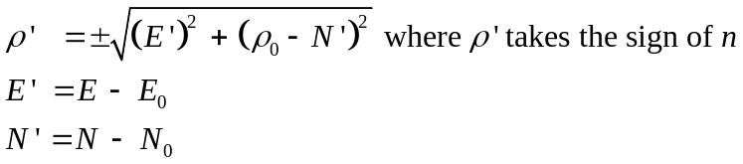
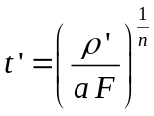

Grid convergence
Grid convergence is the angle at a point between true and grid North. It is positive when grid North lies to the West of true North.
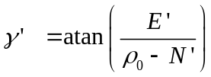

Easting conversion
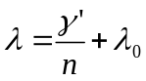

Northing conversion
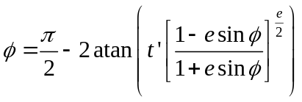
which is solved iteratively, the initial value of is
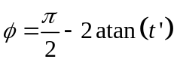

Point scale factor
The scale factor (k) is calculated at a point away from the standard parallels.



