Application for consent to construct water storage infrastructure
You need written consent to construct water storage infrastructure on a Crown pastoral lease.
Water storage infrastructure usually includes:
- all constructed water systems within a watercourse upstream of and where a dam structure is to be located, and includes dams, weirs, reservoirs, and impoundments,
- all constructed water systems outside a water course where natural runoff will be captured, including dams, dykes, reservoirs, impoundments, and associated soil disturbance, and ponds that store rainwater for farming,
- water storage tanks outside the existing curtilage of dwellings,
- an artificial watercourse for water storage, including a headrace canal (a headrace canal is classified as a dam under the Building Act 2004 because of the volume of water it retains and its depth),
- a groundwater replenishment scheme, including injection systems.
Water storage infrastructure excludes:
- water supply systems such as pipeline constructions, conveyancing systems, and water treatment plants, ‘downstream’ from the main source of supply (water storage),
- systems that may pump and convey water from another catchment.
If you want to undertake any other activity affecting or disturbing soil you will need to complete the discretionary pastoral activity application form for disturbing soil.
To apply for consent to construct water storage infrastructure, complete this form.
You must provide enough information to allow the Commissioner of Crown Lands (the Commissioner) to decide on your application. To avoid delays, we recommend providing as much information as possible. We will contact you if more information is required, or if we need to seek information from other sources. If we cannot get sufficient information, your application may be declined.
At a minimum, please check you have provided:
- your details
- details about the property
- details about your proposed activity
- details about your proposed activity’s location, including a map
- a description of any potential effects of the proposed activity on inherent values (see the Inherent values framework)
The Commissioner may consider other matters they consider relevant to the application.
As part of processing your application, your form and supporting information may be shared with other parties. More information on this process can be found at the back of this form.
If you have any questions about what is required, email your Portfolio Manager or pastoral@linz.govt.nz
Please send your completed form and any supporting information to your Portfolio Manager. If you do not know who your Portfolio Manager is, send it to pastoral@linz.govt.nz
You can also send it by post to:
Pastoral team
Toitū Te Whenua Land Information New Zealand
Private Bag 4721
Christchurch 8140
Further information on the consenting process can be found at the back of this form. We recommend you read this section carefully before submitting your application.

Your details
Your full name
Click or tap here to enter text.

The registered lessee or licensee’s name
Click or tap here to enter text.

Your relationship to the lease or licence, for example, ‘lessee’ or ‘farm manager’
Click or tap here to enter text.

Your phone number Your email address
Click or tap here to enter text. | Click or tap here to enter text.

Property details
Name of the lease or licence
Click or tap here to enter text.

Address
Click or tap here to enter text.

Please list any other applications that are being submitted with this form so we can consider them together
Click or tap here to enter text.

Authorisation
By signing this form, you confirm that:
- you have the authority to make this application,
- you acknowledge that this application may be shared, and
- this application is accurate and complete to the best of your knowledge.
Signature Date
Click or tap here to enter text.

Details of the proposed activity
Describe the activity or activities you are proposing. Include detailed information on site preparations such as levelling or spraying and the method(s) you will use for the construction.
Note any third-party involvement and detail your post-activity management plan describing how you will manage the area after the activity. If you have a farm plan relevant to your proposal, you may wish to attach relevant sections to the back of this form to support your application.
Click or tap here to enter text.

Activity specifications
What date will you start the works, how long will they last, and what is the anticipated end date? | Click or tap here to enter text.
What is the total land area that will be affected/disturbed? | Click or tap here to enter text.
Describe any cut or fill batters, or both. Include height, depth of excavation, slope and extent. | Click or tap here to enter text.
For earthworks, where will you dispose of cleared material? | Click or tap here to enter text.
Will you be stockpiling any material?  If yes, please describe the dimension, location and duration of stockpiles | Click or tap here to enter text.

Is the construction in the bed of a waterway (such as a dam)?
Describe any aquatic life present in the watercourse (such as fish, invertebrates, aquatic and riparian vegetation, and associated aquatic waterfowl).
Click or tap here to enter text.

If you are proposing to construct a dam

If you are applying to construct a dam, answer the following questions. Otherwise skip to the section ‘skip to here if you are not proposing to construct a dam’.

Have you employed a professional advisor to design the dam? If yes, give details.

Please note that for larger dams of greater than “low” risk, a professional engineering report may be required. See New Zealand Dam Safety Guidelines (2015) and the Building (Dam Safety) Regulations 2022, which come into force May 2024

Click or tap here to enter text.

What building materials will the dam/weir be constructed from?
Click or tap here to enter text.

Describe the foundation conditions at the site and specific construction methods such as excavation and key-in requirements, the junction between the shoulders and the dam, and the compaction requirements.
Click or tap here to enter text.

What is the approximate size of the upstream catchment?
Click or tap here to enter text.

What is the volume of the dam reservoir or impoundment of water, and the surface area of the impoundment of water when water is at overflow pipe or spillway level? Will this comply with the Building (Dam Safety) Regulations 2022?
Click or tap here to enter text.

Describe your long-term management and maintenance plan, for example shingle/sediment.
Click or tap here to enter text.

What is the intended life of the dam?
Click or tap here to enter text.

Describe any temporary works in the stream bed that are proposed to facilitate dam construction.
Click or tap here to enter text.

Describe any permanent works in the streambed and outside a water course where natural runoff will be captured.
Click or tap here to enter text.

Describe the pattern of land inundation that will occur when the proposed dam is full. You can provide the pattern on your locality or farm map.
Click or tap here to enter text.

Will the dam cause any cross-boundary inundation or damage to another property, lease or licence?
Provide the dimensions (in metres) against the numbers shown on the diagrams, in the lists below. If the dam design is different from that shown, please include an accurate diagram showing all dimensions.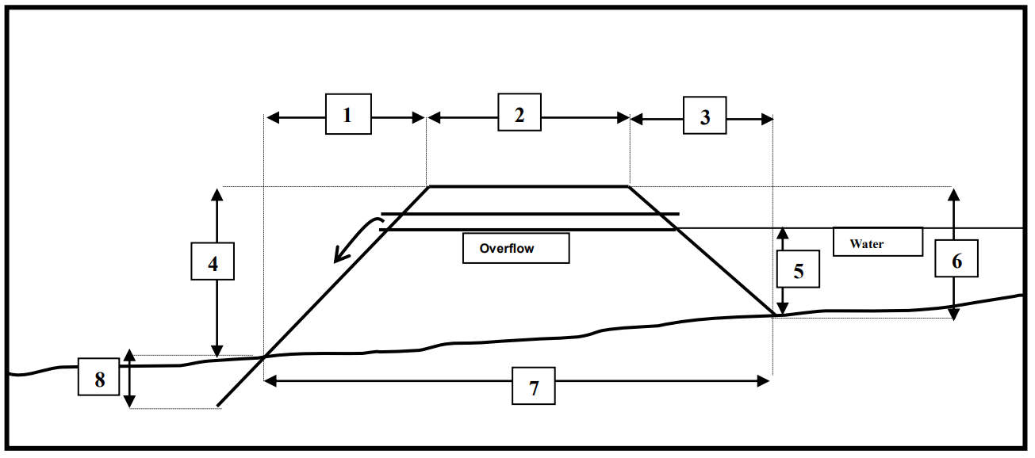
- Downstream batter width: ____________
- Crest width: ____________
- Upstream batter: ____________
- Downstream batter height: ____________
- Overflow pip height or spillway crest: ____________
- Upstream batter height: ____________
- Dam base width: ____________
- Depth dam is to be keyed into existing ground: ____________

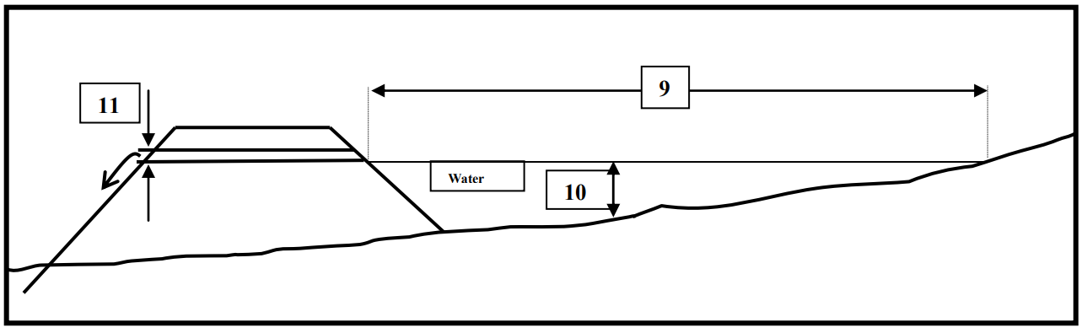
- Length of pond behind dam: ____________
- Maximum depth of reservoir: ____________
- Diameter of overflow pipe: ____________
Provide an initial assessment of dam-break flood hazard (and consequence).
Click or tap here to enter text.

Have you identified any hazards that may impact on the dam structure?
Click or tap here to enter text.

Describe the spillway surface material and the material used for erosion protection of dam faces.
Click or tap here to enter text.

Skip to here if you are not proposing to construct a dam

Site details
Describe the site(s) where you propose to construct water storage infrastructure. Include information on the land (for example contour, aspect, and altitude), vegetation and ground cover, any waterway crossings (for example; dry or flowing, distance from activity), and predominant soil type at the site(s).
Click or tap here to enter text.

Include a map with your application that shows where you want to construct water storage infrastructure in relation to:

- roads and tracks
- lease/licence boundaries
- neighbouring properties
- watercourses
- wetlands
- existing structures and buildings
- historic sites
- inherent values
- identified sites of cultural significance
- other relevant features of the surrounding environment
Your map can be a detailed sketch, plan, topographic map, or aerial photograph. You can request a topographic map from your Portfolio Manager or pastoral@linz.govt.nz.

Do you need any resource consents or permits?
Describe any resources consents or permits you need to undertake the activity. Note whether you have already obtained these consents or permits or explain your plan or the process required to obtain them.
If you wish to dam for water storage, you may need resource consent from a regional council. You may also need a building consent. All dams regardless of size must comply with the building code. For dams that have a height of 4 or more metres and hold 20,000 or more cubic metres of water, a building consent will be required. If you are unsure, contact your Portfolio Manager.
Click or tap here to enter text.

Is the activity necessary?
Explain why this activity is necessary. Things we will consider include whether it is needed to:
- enable pastoral farming under the lease or licence,
- continue a regular cycle to maintain existing pasture created by oversowing, top-dressing, or cultivation,
- provide access to land that’s being oversown or top-dressed for livestock grazing,
- use, maintain, or replace consented existing infrastructure or buildings,
- help you meet your obligations under any other law,
- ensure the ongoing financial viability of the pastoral farming enterprise, or
- address an exceptional circumstance.
Click or tap here to enter text.

Inherent values
See further information on inherent values at the back of this form.
Describe the inherent values that are likely to be affected by the proposed activity. How important are these values?
Click or tap here to enter text.

What effects could the proposed activity have?
Describe any adverse effects (including any cross-boundary effects) the proposed activity may have on the site’s inherent values. Explain the projected level of impact of these effects on these values.
Click or tap here to enter text.

Describe any adverse cross-boundary effects the proposed activity may have on neighbouring persons or land.
Click or tap here to enter text.

How will you mitigate these adverse effects?
Describe what you will do to help prevent, remedy, or reduce any adverse effects of the activity described above. Include safeguards and contingency plans where relevant. Once these actions have been taken, what will the remaining effects be?
Click or tap here to enter text.

Have you considered alternatives to the activity?
Describe the alternative activities you’ve considered that would have less impact on inherent values. Explain why you have not pursued these alternatives.
Click or tap here to enter text.

Is there any other relevant information that we should consider with your application?
For example, any further context for the activity that you would like to share.
Click or tap here to enter text.

Further information
We will process your application as quickly as possible. The time it takes will be affected by how much information you have provided, the complexity of the proposed activity, and the values at the site the activity is proposed for.
The Commissioner must consult with the Director-General of Conservation and iwi with interests in the area before deciding on your application. This is to identify any inherent values at the site and their relative importance. It may include a site visit. Please advise us if there is sensitive information in your application that you would like withheld from these parties under the Official Information Act 1982 or Privacy Act 2020.
If your request is granted, you must read your consent terms carefully. The Commissioner may require you to undertake maintenance if your application is approved. The Commissioner may monitor whether the conditions set out in your permit are complied with.
If you do not provide sufficient information to be able to assess your application, your application may be declined and a Notice of Decision will be sent which explains the reason(s) for that decision. If the Commissioner declines to accept your application and you do not agree with the Commissioner’s decision, you may request a rehearing. To request a rehearing, you must advise the Commissioner in writing within 21 calendar days. You can send your request for a rehearing to your Portfolio Manager.

Natural resources and inherent values
This form asks you about the natural resources of the land, and the inherent values of those resources. Inherent values are a natural resource’s ecological, landscape, cultural, heritage, or scientific values. Natural resources include any:
- plants and animals
- air, water, or soil in which plants or animals may live
- landscape and landforms
- geological features
- ecosystems

Other things to be aware of when making this application
A summary of most decisions made by the Commissioner will be published on the Toitū Te Whenua Land Information New Zealand website. Please advise us if there is sensitive information in your application that you would like withheld from publication under the Official Information Act 1982 or Privacy Act 2020.
The Commissioner must consider Crown Pastoral Land Act 1998 outcomes and criteria when making a decision. You may wish to reference these in your application.

Key documents
We have created guides to help you navigate changes to the Crown Pastoral Land Act 1998.
You can apply for permission for other activities by completing the correct application form.

